Quantum Computing Lecture Notes

# Week 1

## Logic gates

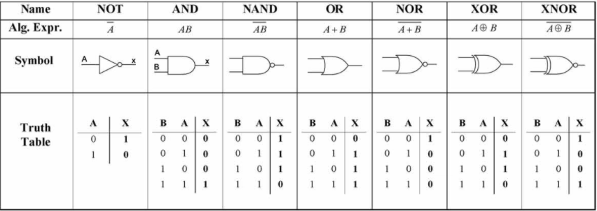

NOT: Flips the bit

FANOUT: Copies the bit

UNIVERSALITY: Any computation can be made by using a combination of {NOT, AND, OR, FANOUT}

REVERSIBILITY: Given the output of a gate, we can determine what the inputs are.

# Week 2

## Superposition

Qubit: |𝜓⟩ = 𝛼|0⟩ + 𝛽|1⟩

Measurement collapses the quantum state of the qubit |𝜓⟩ to either |0⟩ or |1⟩

probability of measuring |0⟩: 𝛼²

probability of measuring |1⟩: 𝛽²

where 𝛼² + 𝛽² = 1

## Quantum Gates: single qubit

### X (bit-flip) gate

X|0⟩ = |1⟩

X|1⟩ = |0⟩

### Z (phase) gate

Z|0⟩ = |0⟩

Z|1⟩ = -|1⟩

### H (Hadamard) gate

H|0⟩ = 1/√2|0⟩ + 1/√2|1⟩ = (|0⟩ + |1⟩) / √2

H|1⟩ = 1/√2|0⟩ - 1/√2|1⟩ = (|0⟩ - |1⟩) / √2

## Gates Applied to Superposition

X|𝜓⟩ = X(𝛼|0⟩ + 𝛽|1⟩) = 𝛼(X|0⟩) + 𝛽(X|1⟩) = 𝛼|1⟩ + 𝛽|0⟩

Z((|0⟩ + |1⟩) / √2) = (Z|0⟩ + Z|1⟩) / √2 = (|0⟩ - |1⟩) / √2

H((|0⟩ + |1⟩) / √2) = (H|0⟩ + H|1⟩) / √2 = |0⟩

## Quantum Interference

Result of two classical coin flips: 50 % 0 , 50 % 1

Result of two hadamard gates on |0⟩: 100 % |0⟩

1/2|0⟩ + 1/2|0⟩ = 1|0⟩

1/2|1⟩ - 1/2|1⟩ = 0|1⟩

The states involved in quantum superposition can cancel or amplify

## Two-qubit states

|00⟩ or|0⟩|0⟩ : qubit A is |0⟩ and qubit B is |0⟩

|01⟩ or|0⟩|1⟩ : qubit A is |0⟩ and qubit B is |1⟩

|10⟩ or|1⟩|0⟩ : qubit A is |1⟩ and qubit B is |0⟩

|11⟩ or|1⟩|1⟩ : qubit A is |1⟩ and qubit B is |1⟩

## Quantum Gates: two-qubits

CNOT (controlled not) gate

if the control qubit is 0, does nothing

if the control qubit is 1, flip the target qubit

CNOT|00⟩ = |00⟩

CNOT|01⟩ = |01⟩

CNOT|10⟩ = |11⟩

CNOT|11⟩ = |10⟩

acts like XOR on target in classical logic gates

## Quantum Entanglement

Quantum correlation between two qubits where the state of one qubit depends on the other qubit

Entangled state: |𝜓⟩ = 1/√2|00⟩ + 1/√2|11⟩

if we measure |𝜓⟩

● we get |00⟩ with 50 % probability

● we get |11⟩ with 50 % probability

if we measure only qubit A:

● if qubit A is 0 the quantum state of qubit B is immediately set to |0⟩

● if qubit A is 1 the quantum state of qubit B is immediately set to |1⟩

## How to Create Quantum Entanglement

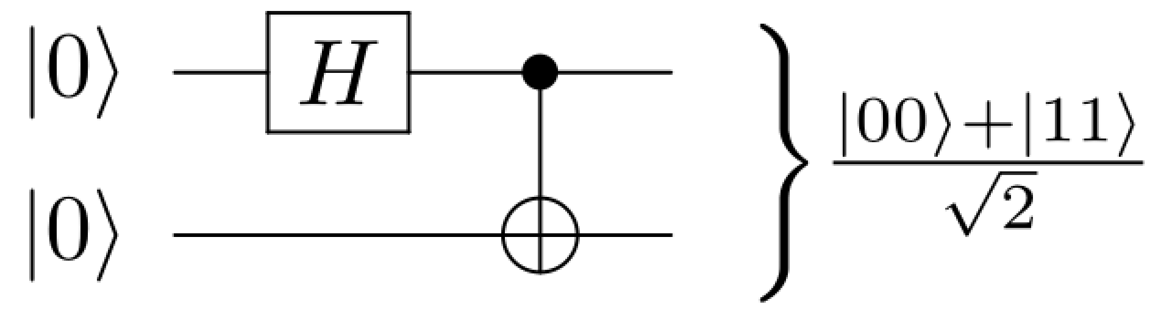

H|0⟩ = (|0⟩ + |1⟩) / √2

CNOT|(|0⟩ + |1⟩) / √2⟩|0⟩ = either |00⟩ or |11⟩

# Week 3

## Intro to Vectors

### Scalar

• A quantity having only magnitude (no direction).

• What we typically think of when we think of numbers.

• Written as: a ∈ ℝ

• Some examples in physics:

• Distance (m)

• Speed (m/s)

• Time (s)

• Mass (kg)

### Vector

• A quantity with both magnitude and direction.

• Can be described by a list of scalars (Cartesian form) or a radius and an angle (Polar form).

• Written as: v ∈ ℝn

• Some examples in physics:

• Displacement (m)

• Velocity (m/s)

• Acceleration (m/s2)

• Weight (N)

General 2D Vector Notation: 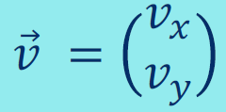

Vector Magnitude: 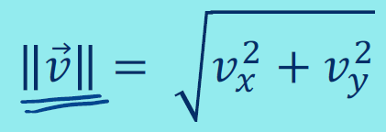

Vector Direction: 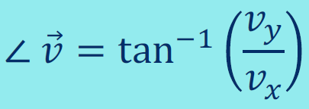

Vector Addition: 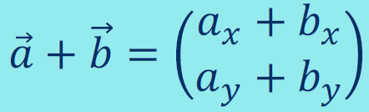

Vector-Scalar Multiplication: 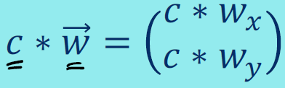

Vector Decomposition: 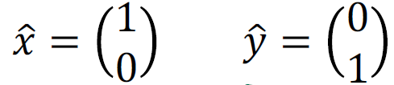

Every vector can be expressed as a linear combination of 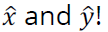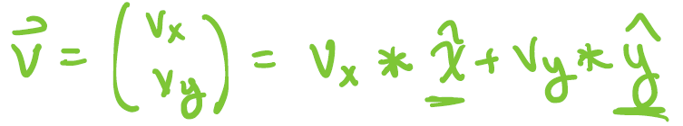

## Intro to Complex Numbers

Solving for roots of quadratic equations: b2-4ac < 0

The Imaginary Unit: *i* = √-1 or i2 = -1

A complex number consists of both a real and imaginary component: z = a + *i*b

Complex numbers can additionally be represented as vectors: 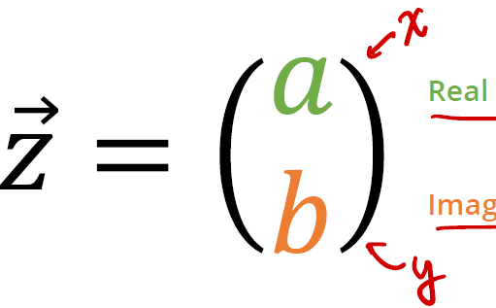

Complex Number Addition: 

Complex Number Multiplication: 

Complex Number Conjugation: 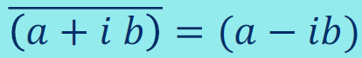

Complex Number Modulus: 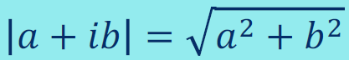 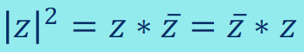

Euler’s Formula: 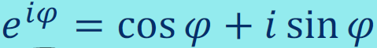

Polar Representation: 

Vector Radius: 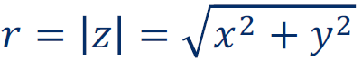

Vector Angle: 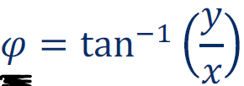

Euler’s Identity: 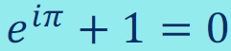

Complex Exponentials Addition: 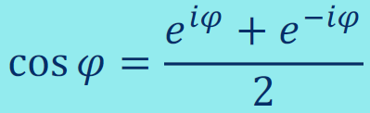 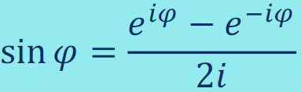

Complex Exponentials Multiplication: 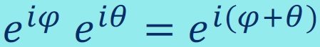

Complex Exponentials Conjugation: 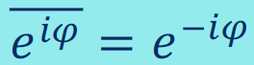

Complex Exponentials Modulus: 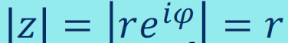

Multiply by *i* to rotate by 90o: z1 = 1, z2 = i, z1.z2 = *i* or z1 = 2+3*i*, z2 = i, z1.z2 = -3 + 2*i*

# Week 4

## Vectors in Quantum Computing

### Bloch Sphere

Qubits are two-level quantum systems that lie in the Bloch sphere and their states can be represented as vectors:

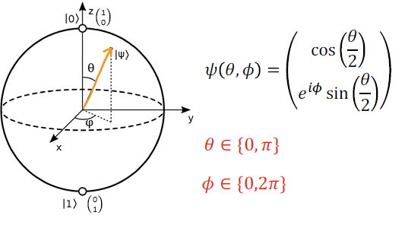

### More Vectors

Vector Shape: 

Column Vector: nx1

Row Vector: 1xm

Vector Transpose: Operation to flip the shape of a vector. (Rows become columns and columns become rows.) The transpose does not change anything about the vector geometrically. It just changes the shape.

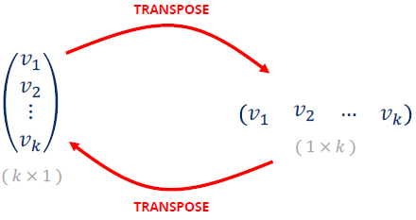

Inner product of two real vectors: Dot product or scalar product since it maps vectors to a scalar.

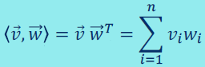

Vector Magnitude: The inner product of a vector with itself gives us the magnitude squared of the vector. The magnitude of the vector is also called its norm.

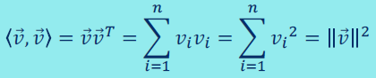

Vector Normalization: A vector is normalized if it has a magnitude of 1. A normalized vector is often called a unit vector. To normalize a vector, dividing it by its magnitude.

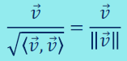

Inner product in geometry tells us the angle between two vectors:

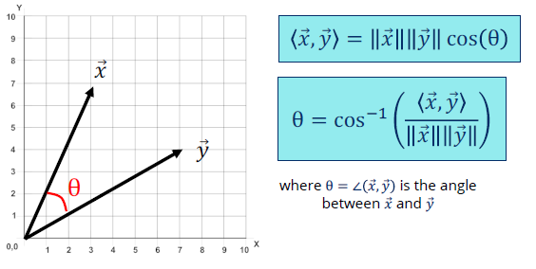

Vector Orthogonality: When 𝑥 and 𝑦 are unit vectors, <𝑥, 𝑦> = cos θ, and the inner product is a similarity measure between vectors:

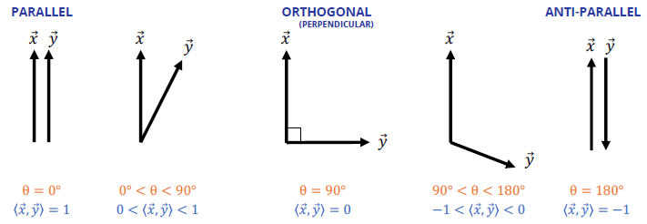

Conjugate Transpose: The complex conjugate is also sometimes also called the Hermitian conjugate:

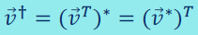 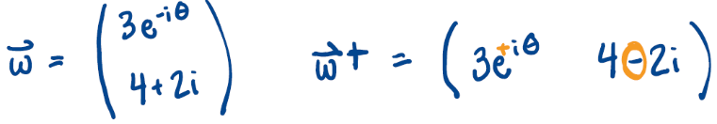

Inner Product for Complex Numbers: Calculate the magnitude of a complex vector. DO NOT USE the standard inner product. Transpose one of the vectors to multiply a row vector with a column vector:

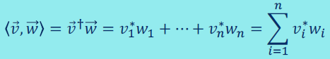

Linear Combinations: A linear combination of a set of terms is simply the addition of those terms multiplied by scalar coefficients. In the case of vectors, a linear combination is simply a weighted sum of vectors:

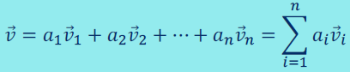

In the case of quantum states, a superposition is simply a linear combination of quantum states:



## Intro to Matrices

Quantum states are represented as vectors. However, in quantum computing, our goal is to manipulate these states, to run quantum algorithms. To do so, we use quantum gates, which are represented as matrices.

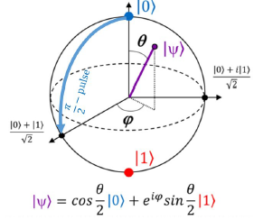

Matrix: A collection of row vectors or a collection of column vectors. Geometrically, matrices are transformations that allow us to both rotate and scale vectors.

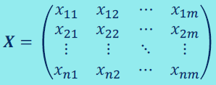

Matrix Addition: You can only add matrices of the same shape.

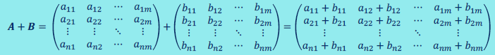

Matrix-Scalar Multiplication:

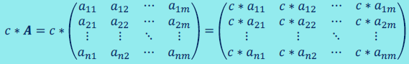

Matrix-Vector Multiplication: The vector height must match the matrix width.

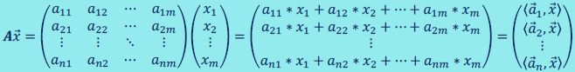



Matrix-Matrix Multiplication: The first matrix width must match the second matrix height.

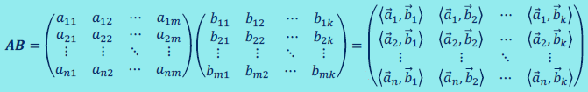



Matrix Transpose: Flip the matrix its diagonal.

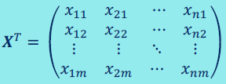



Matrix Conjugate Transpose: The same as a matrix transpose but conjugate any complex numbers in the matrix.

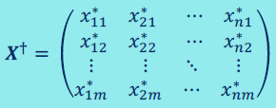

Identity Matrix: 1s along the diagonal and 0s on off-diagonals.

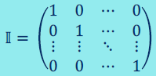

Multiplication by the identity matrix is analogous to scalar multiplication by 1:



Matrix Inversion: For a given matrix 𝑿, 𝑿-1 is the inverse if:



Many matrices do not have inverses.



Linear Systems of Equations:

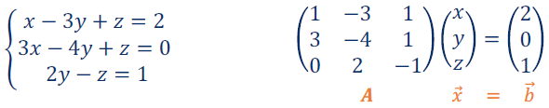

A-1Ax = A-1b => x = A-1b

Using Matrices to Transform Vectors: Transformation Matrix * Input Vector = Output Vector

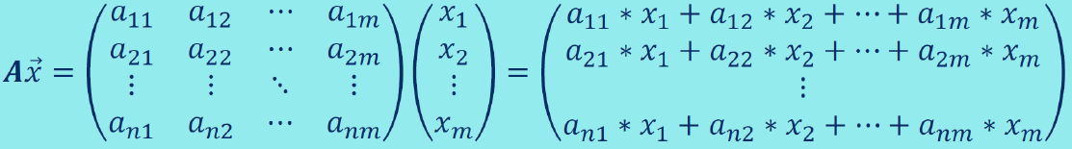

• Quantum gate: matrix

• Qubit: vector

• Operating a quantum gate on a qubit: multiplying matrix with vector

X|0⟩ = |1⟩

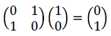

H|1⟩ = 1/√2|0⟩ - 1/√2|1⟩

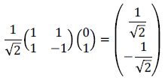

• Operating multiple gates on a qubit: matrix multiplication and multiplying matrix with vector

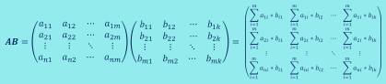

H and X on |1⟩:

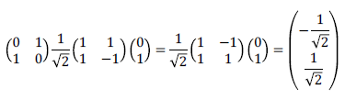

Matrix Inversion on H:

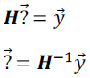

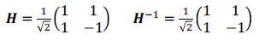

# Week 5

## Intro to Probability

### Set

A set is a collection of distinct objects, which can be considered an object. The arrangement order of objects in a set does not matter. The elements of a set can be anything from numbers to people to colors.

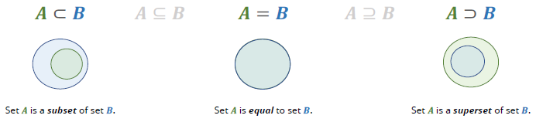

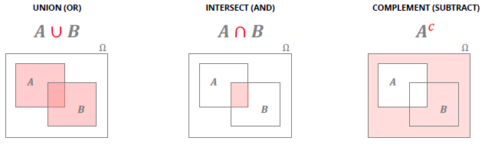

### Probabilistic Model

A probabilistic model is a way to mathematically describe an unknown situation. There are two key components: (1) sample space and (2) probability law.

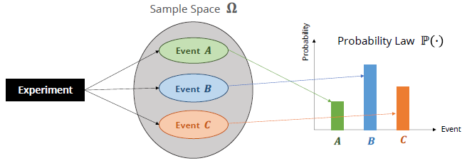

### Sample Space

We denote all the events in the sample space using set notation: 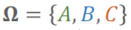

Sample space of a coin toss: 

Space for two-coin toss: 

Different states qubit will collapse to upon measurement: 

Sample space of a 6-sided die toss: 

Elements of the sample space (Ω) must be distinct and mutually exclusive (two events can’t occur simultaneously) so that when an experiment is carried out there is a unique outcome, i.e. no elements in intersection.

The sample space (Ω) must be collectively exhaustive, such that no matter what happens in an experiment, we always obtain an outcome in the sample space, i.e. no new elements.

### Probability Law

A probability law assigns to each event, 𝒀, a non-negative number, ℙ(𝒀), that encodes our knowledge/belief about the collective likelihood of elements of 𝒀.

Probability law for a fair coin toss: P(H) = ½ P(T) = ½

### Fundamental Axioms of Probability

1. NONNEGATIVITY: The probability of every event in the sample space must be greater than or equal to zero.

ℙ(𝑨) ≥ 0, for every event 𝑨

1. ADDITIVITY: If 𝑨 and 𝑩 are two disjoint events, then the probability of their union is the sum of their individual probabilities.

ℙ(𝑨 ∪ 𝑩) = ℙ(𝑨) + ℙ(𝑩)

1. NORMALIZATION: The probability of the entire sample space (Ω) is equal to 1.

ℙ(𝛀) = 1

### Other Properties of Probability

* Probability of empty set = 0 because ℙ(𝛀) = 1
* Probability of 𝑨c = 1 - ℙ(𝑨)
* If 𝑨 ⊆ 𝑩, then ℙ(𝑨) ≤ ℙ(𝑩)
* ℙ(𝑨 ∪ 𝑩) = ℙ(𝑨) + ℙ(𝑩) − ℙ(𝑨 ∩ 𝑩)  
  Thus, ℙ(𝑨 ∪ 𝑩) ≤ ℙ(𝑨) + ℙ(𝑩)
* ℙ(𝑨 ∪ 𝑩) = ℙ(𝑨) + ℙ(𝑨c ∩ 𝑩)

### Discrete Random Variables

Frequently, outcomes of probabilistic models are numerical (i.e. instrument readings, stock prices). In other cases, the outcomes may not be numerical, but may be associated with numerical values of interest (i.e. in a group of people, we might care about their height).

Random Variable (RV): a function that assigns a numerical value to each possible outcome of the experiment. Even though it is called a random variable, it is a function that maps elements from the sample space 𝛀 to ℝ.

***X***: 𝛀 → ℝ

### Probability Mass Functions

Every discrete random variable has an associated probability mass function (PMF), which gives the probability of each numerical value that the random variable can take. It is a means of describing the discrete probability distribution.

Now suppose we are betting on a fair coin flip. You win $1 if it is heads and lose $1 if it is tails.

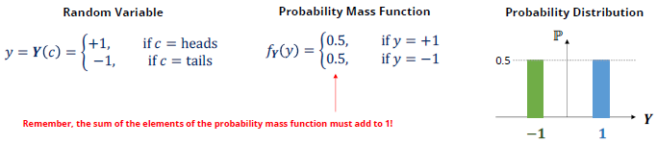

### Expectation

The expectation is the weighted (in proportion to the probabilities) average of the possible values of a random variable. It is sometimes referred to as the mean of a random variable or center of gravity of the PMF. It’s a linear combination.

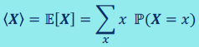

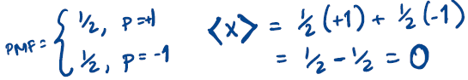

Expectation of a 6-sided die toss:

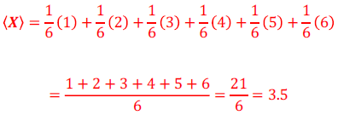

### Variance

The variance is expected value of the random variable (𝑿 – 𝔼[𝑿])2 and provides a measure of the dispersion of 𝑿 about its mean.

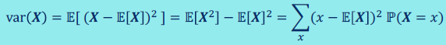

### Law of Large Numbers

The average of a large number of trials should be close to the expected value, and it will tend to become closer to the expected value as the number of trials increases.

### Dirac Notation

Paul Dirac established the most general theory of quantum mechanics and discovered the relativistic equation for the electron. He introduced Dirac or bra-ket notation.

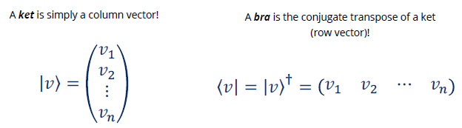

Ground State: 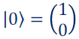

Excited State: 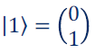

Superposition State: 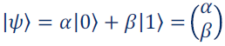



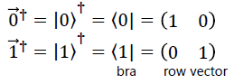

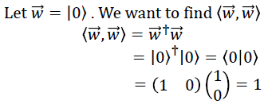

1-Qubit States:

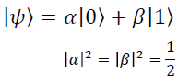

2-Qubit States:

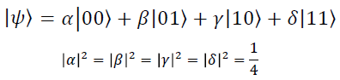

Entanglement:

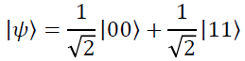

Inner product examples:

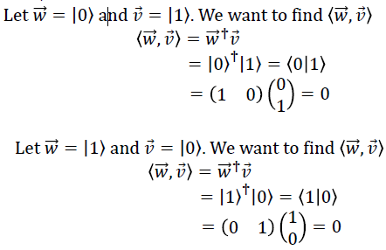

# Week 6

## Intro to Python – Part 1

Algorithm: A set of steps to complete a problem.

Code Editor: Repl.it

Print Statements: print(“Hello”)

Comments: Anything that comes after a pound sign (#) does not get run by the Python program

Variables: Something that gets assigned a value for future use.

Variable Types: Integer, Float, String, List, Boolean

Variable Names: cannot start with a number, cannot contain spaces, cannot contain special characters ($, &, @, !, [, }), cannot be a python reserved word like “with” or “not”.

Arithmetic Operators: +, -, *, /

Comparison Operators: >, >=, <, <=, ==, !=

Boolean Operators: and, or, not

List Examples:

* list1 = [“bananas”, “strawberries”, “peaches”]
* list2 = [5, 10, 15, 20]

Extracting Items from a List: list1[0] # first element, i.e. bananas

Adding to a List: list1.append(“oranges”)

Removing from a List: list1.remove(“peaches”)

Storing input in a variable: firstName = input(“Enter your first name: ”)

# Week 7

## Intro to Python – Part 2

### If Statement (Conditionals)

if a > b:

print(“a is greater”)

elif a > b:

print(“b is greater”)

else:

print(“a is equal to b”)

### For Loop

fruits = ["apple", "banana", "cherry"]

for x in fruits:

if x == "apple":

continue # jump to the next item in the loop

elif x == "banana":

break # leave the loop

else:

print(x)

for x in range(5):

print(x) # print 0, 1, 2, 3, 4

for x in range(2, 5):

print(x) # print 2, 3, 4

for x in range(2, 10, 3):

print(x) # print 2, 5, 8

### While Loop

i = 1

while i < 6:

if i == 3:

continue

elif == 4:

break

else:

print(i)

i += 1

### Functions

def calculateArea(base, height):

area = base * height

return area

### External Libraries

import math

import numpy as np

# Week 8

## Math for Quantum – Part 1

### Dirac (bra-ket) Notation

Dirac or bra-ket notation allows us to abstract away parts of the complicated underlying math for quantum mechanics

ket (| ⟩): can be represented with a column vector.

bra (⟨ |): can be represented with a row vector. The bra is the complex-conjugate of the ket.

|c> = a|0> + b|1> => <c| = a*<0| + b<1|

Ex. |c⟩ = 1/√2|0⟩ + 1/√2|1⟩ => <c| = 1/√2<0| + 1/√2<1|

Ex. |c⟩ = 1/√2|0⟩ + i/√2|1⟩ => <c| = 1/√2<0| - i/√2<1|

### Inner Product

Inner product finds the overlap between two quantum states braket (bra+ket): ⟨ψ│φ⟩

<0|0>: 1

<1|0>: 0

<0|1>: 0

<1|1>: 1

Two states |ψ⟩ and |φ⟩ are “orthogonal” if: ⟨ψ│φ⟩ = 0 (orthogonal = perpendicular)

State |ψ⟩ is “normal” if: ⟨ψ│ψ⟩ = 1

Measurement collapses the quantum state of the qubit |𝜓⟩ to either |0⟩ or |1⟩

Qubit: |𝜓⟩ = 𝛼|0⟩ + 𝛽|1⟩

Probability of measuring |0⟩: |𝛼|2

P(0) = |<0|𝜓⟩|2 = |<0|(𝛼|0⟩ + 𝛽|1⟩)>|2 = |𝛼|2

Probability of measuring |1⟩: |𝛽|2

P(1) = |<0|𝜓⟩|2 = |<1|(𝛼|0⟩ + 𝛽|1⟩)>|2 = |𝛽|2

### Quantum Operation

Transforms a quantum state to another such as quantum gates. We can represent them as matrices.

### Important Quantum Operators

Pauli operators:

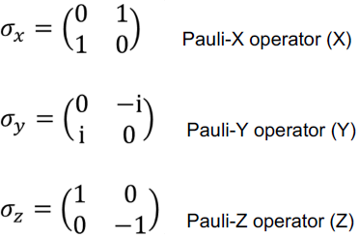

|0> = |1>

|1> = |0>

|0> = i|1>

|1> = -i|0>

|0> = |0>

|1> = -|1>

Linearity:

(1/√2|0⟩ + 1/√2|1⟩) = 1/√2(|0⟩) + 1/√2(|1⟩) = 1/√2|0⟩ - 1/√2|1⟩



Composition:

(|0⟩) = |1⟩ = -|1⟩

()|0⟩ = -|1⟩

Order matters:

(|0⟩) = -|1⟩

((|0⟩) = |1⟩



Conjugate Transpose:



Hermitian Operators:

All observable operators are Hermitian. Example: Position, Momentum, Energy

Hermitian:  operator is equal to its own conjugate transpose.

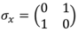

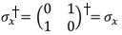

Reversibility:

Given the output of a gate, we can determine what the inputs are.

Unitary Operators:

All reversible quantum operations are unitary. Example: Time evolution

All quantum gates are unitary.

Unitary: A.A† = A†.A = I (identity matrix)

A† = A-1

# Week 9

## Math for Quantum – Part 2

### Vector Spaces

A vector space is a collection of vectors which can be added and multiplied, adhering to the following axioms:

1. x + y = y + x

2. x + (y + z) = (x + y) + z

3. There is a unique zero vector (0), such that x + 0 = x

4. For each x there is a unique −x, such that x + −x = 0

5. 1x = x

6. (ab)x = a(bx)

7. a(x + y) = ax + ay

8. (a + b)x = ax + bx

For all x, y, z ∈ 𝓥 (vector space) and a, b ∈ ℂ (complex numbers)

Linearly Independence:



Orthogonal vectors are linearly independent.



Span:

If a vector space 𝓥 consists of all linear combinations of  then these vectors span 𝓥.

In other words, if every vector 𝑣 ∈ 𝓥 can be expressed as  span 𝓥.

Basis:

A basis for the vector space 𝓥 is the set of vectors having the following two properties at once:

1. The vectors are linearly independent (not too many vectors)

2. The vectors span 𝓥 (not too few vectors)

Thus, every vector in the vector space 𝓥 is a unique linear combination of the basis vectors.

However, every vector space has infinitely many bases.

Hilbert Spaces:

In quantum computing, you will often hear the term Hilbert space. Although this may sound scary, it is

simply a vector space equipped with an inner product.

### Eigenvectors & Eigenvalues

Typically, multiplying a matrix and vector results in a new vector, which is both scaled and rotated. However, if a matrix is multiplied by its eigenvector, the resultant vector is only scaled (no rotation).

In German, “eigen” means proper, characteristic, or own. Our matrix-vector multiplication simplifies to a scalar-vector multiplication:

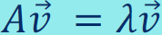 where A is matrix, v is eigenvector of A, and lambda is eigenvalue of A.

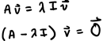

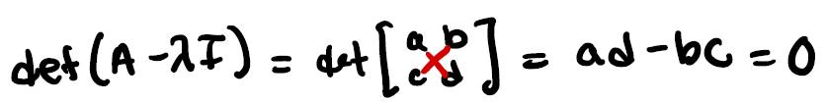

In quantum computing, we are particularly concerned with the eigenvectors of the Pauli matrices, which

are the quantum states along our measurement axes (X, Y, and Z).

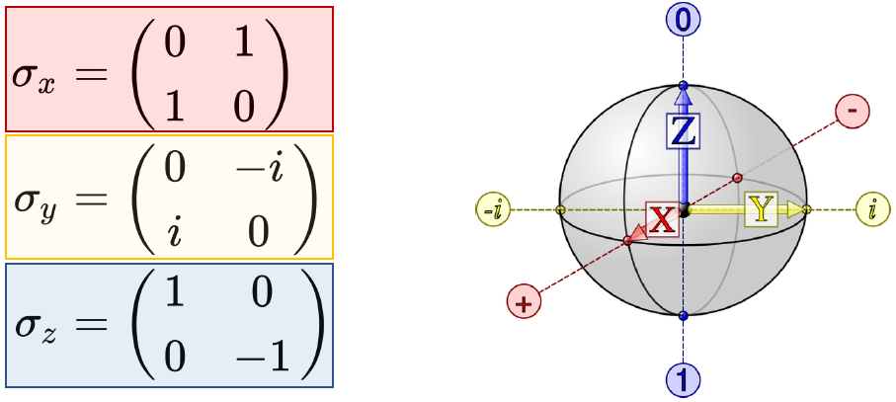

Eigenvalues are +1 and -1 for each of them.

This means that any vector in quantum vector space can be expressed as a linear combination of the eigenvectors of a Pauli matrix.

Eigenvalue corresponding to the eigenvector of a Pauli matrix corresponds to the energy or likelihood of measurement.

# Week 10

## Quantum Stack and Math Review

### Quantum Stack

Full-Stack: The entirety of a computer system or application, comprising both the front end and the back end.

Compiler: A program that translates computer code written in a source programming language to a

target programming language. Oftentimes, the target language is machine code.

Quantum Hardware: Superconducting qubits are controlled via microwave pulse sequences. Different pulse shapes and lengths correspond to different quantum gates.

Qiskit: Quantum program compiler developed by IBM

### Math Review

Quantum states are represented mathematically as complex vectors.

The inner product enables us to compare quantum states and determine their orthogonality.

A linear combination of quantum states is a superposition.

The coefficients in a quantum superposition are probability amplitudes.

To avoid negative and complex magnitudes (not physically possible!), we use the complex inner product.

Quantum operations perform the computation in a quantum computer and are represented

mathematically as matrices.

Quantum measurement is probabilistic.

A probabilistic model is a way to mathematically describe an unknown situation. There are two key components: (1) sample space and (2) probability law.

Dirac (bra-ket) notation is how we mathematically represent quantum states.

Many quantum gates are Hermitian and unitary.

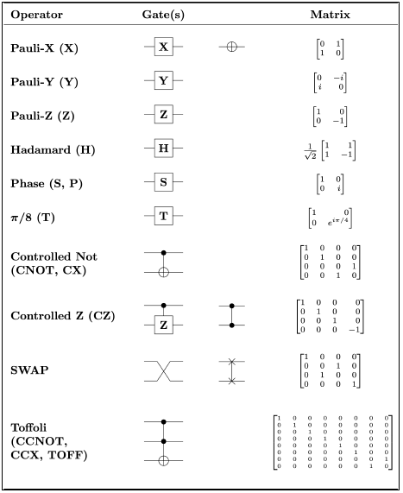

Quantum operation properties:

• Linearity

• Can be composited

• Order matters

All observable operators are Hermitian:

𝑨 = 𝑨t

(operator is equal to its own conjugate transpose)

All reversible operations are unitary:

𝑨𝑨t = 𝑨t𝑨 = 𝑰

(conjugate transpose is matrix inverse)

Quantum states lie in Hilbert spaces, which are just vector space equipped with an inner product.

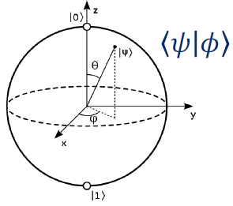

The eigenvectors of the Pauli matrices form bases for the quantum Hilbert space, corresponding to different measurement frames.

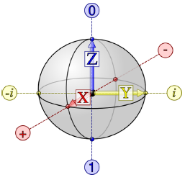

If v is an eigenvector of A, our matrix-vector multiplication simplifies to a scalar-vector multiplication.

# Week 11

## Quantum Mechanics 1 - Principles of Quantum Mechanics

### Quantum Mechanics

Describes how objects behave at a small scale.

● Describes physics at the microscopic level

● Seemingly incompatible with the types of observations made in our everyday lives

● Leads to counter-intuitive effects

● Used for describing the behavior of an atom

The path of an electron around an atom is described by quantum mechanics.

### Quantum Computing

Uses quantum phenomena to perform computation.

● Quantum mechanics is a tool used by quantum computers to solve certain computational problems that normal computers cannot.

● Superposition, entanglement, and interference are the three weird quantum properties that enable the design of quantum algorithms which can compute in ways classical computers cannot, making quantum computers more powerful for solving certain types of problems.

● Quantum Computing is an application of Quantum Mechanics.

● We need to learn quantum mechanics to do quantum computing because qubits are physical systems, and quantum mechanics describes the behavior of these systems

### Particles and Waves

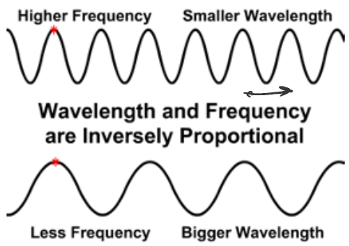

Pre-Quantum Era - Particles:

● Regardless of size, all particles have a well-defined position: you can point to exactly where they are.

● Particles are “discrete”.

● When particles collide, they “bounce off” each other.

Pre-Quantum Era - Waves:

● Unlike particles, waves do not have a well-defined position.

● They are “continuous”.

● When waves “collide”, they will interfere.

Interference:

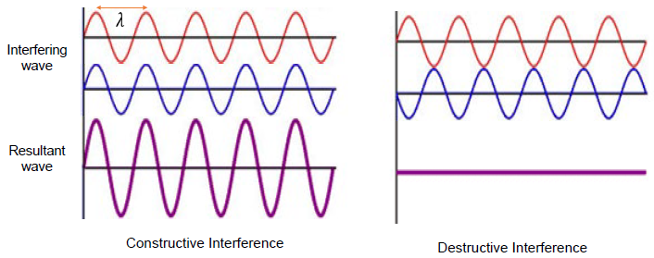

Interference pattern when water is passed through two slits:

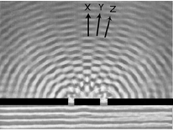

Light as a wave:

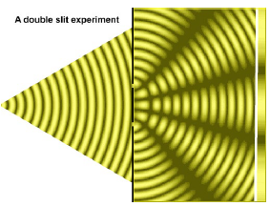

Light as a particle:

The Photoelectric effect:

● No electrons are ejected with low-energy light - no matter how much you use.

● Electrons are ejected with high energy light.

This doesn’t make sense if light is only a wave, because low-energy waves could eventually dislodge the electron. Then it would make sense that no matter how many “particles” of light you use, the electron is not ejected, just like if you tried to use a lot of ping-pong balls to knock over bowling pins. It wouldn’t work. And when you try to use a high-energy “particle” of light to remove the electron, it works! Just like how a bowling ball would work to knock over the bowling pins.

Therefore, light is a wave and a particle (photon).

Wave-particle duality:

In quantum mechanics all objects can be described as both a wave and a particle.

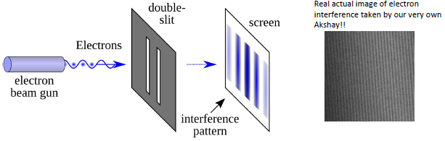

Electrons exhibit wave behavior

De Broglie wavelength:

All particles have a wavelength.

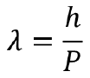

λ: wavelength

h: Planck's constant (6.626x10-34m2kg / s)

P: momentum (m*v)

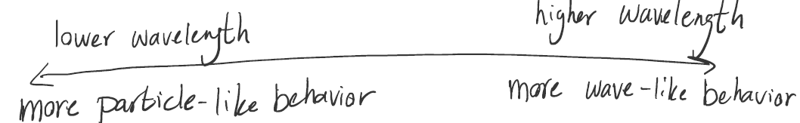

Wifi wavelength: 0.125 m

X-ray wavelength: 10-9 m

Particle positions are defined by a “wavefunction” Ψ(x,t).

psi: (the wavefunction)

x: position

t: time

The wavefunction doesn’t tell you exactly where the particle is. Instead, the wavefunction is a “probability cloud.” It shows how likely it is for a particle to be in a certain region of space at a given time.

Wave-particle duality in quantum computing:

● Qubits behave like waves

● The superposition states of the qubit can interfere with one another

● Using interference, we can amplify the probability of the correct answer

● Quantum interference leads to a quantum speed-up

Hamiltonian:

A quantum operator that gives the energy of a quantum state.

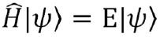

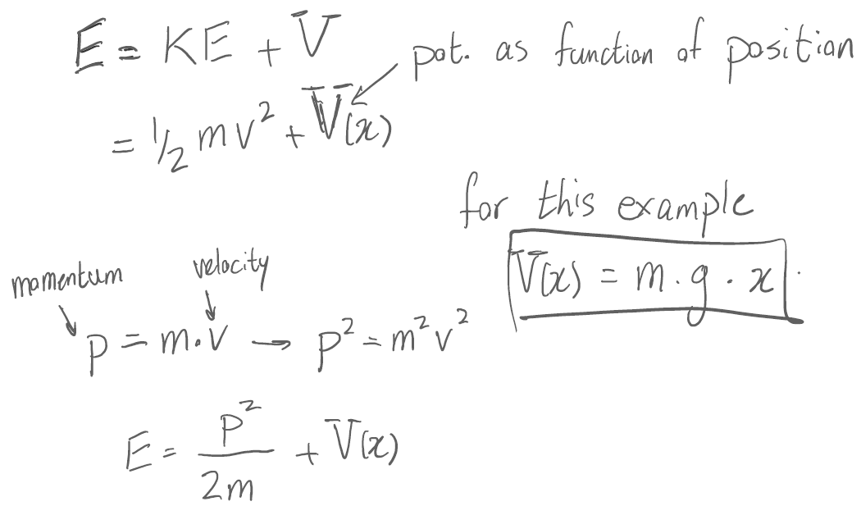

An electron around a nucleus:

Total energy = kinetic energy + potential energy

KE: Energy based on how fast the electron is going

V: Stored energy (not from gravity this time, but from how far the negative electron is from the positive nucleus)

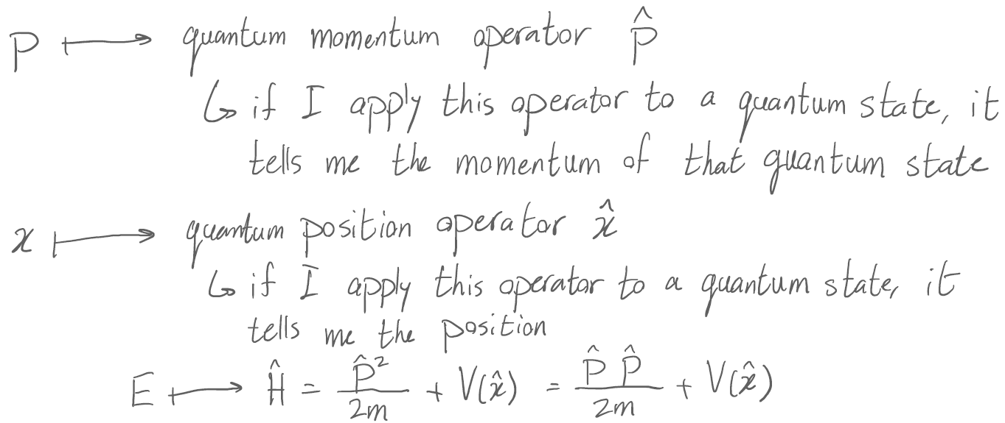

Schrodinger Equation:

● Describes how the wavefunction changes in time based on its Hamiltonian.

● Describes how the quantum state (state of a qubit) changes in time based on its energy values.

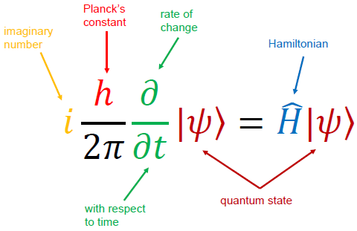

The Schrodinger equation:

● tells us how our quantum hardware behaves

● tells us how to operate our quantum hardware

● allows us to engineer and implement quantum gates

● and many more applications outside of quantum computing in physics and chemistry

Atoms:

● Atoms are made of electrons, protons, and neutrons

● Protons and neutrons are in the nucleus of the atom

● Electrons orbit the nucleus at different distances based on their energy

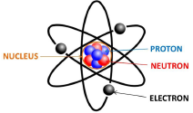

One problem: Accelerating charges (the electron) lose energy. This will cause the electron to eventually collapse into the nucleus.

Bohr’s atom:

● Contrary to classical EM, electrons could orbit in certain discrete stable orbits. Orbits in between are not allowed.

● The stable orbits are those for which the angular momentum of the electron is quantized

● Electrons can only “switch” between orbits of different n by absorbing or emitting a single photon

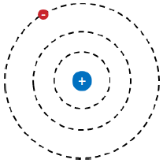

Solution: Electrons can only stay in certain quantized orbits, so they will not eventually collapse into the nucleus.

# Week 12

## Quantum Mechanics 2 - Quantum Two Level Systems and Measurement

### Two-level systems

Two-level system: Qu”bit”: |𝜓⟩ = 𝛼|0⟩ + 𝛽|1⟩

Three-level system: Qu”trit”: |𝜓⟩ = 𝛼|0⟩ + 𝛽|1⟩ + γ |2⟩

Reasons to use two-level system for quantum computing:

● We can map one level to 0 and another level to 1

● They are easier to control

● Simple linear algebraic properties

● Have been studied for nearly a century

## The Stern-Gerlach experiment

Classical magnets:

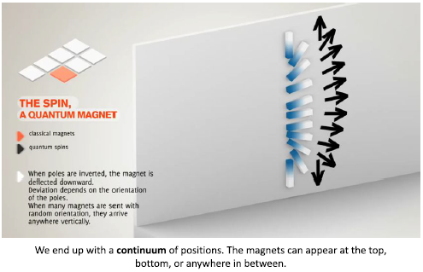

Quantum spins:

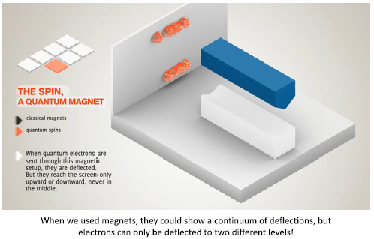

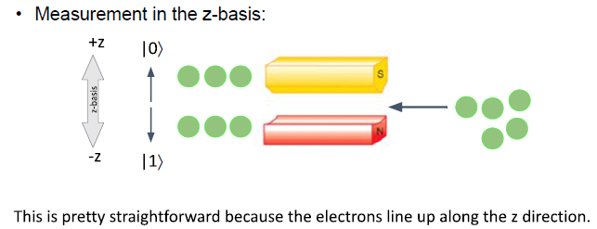

Qubit: |𝜓⟩ = 𝛼|0⟩ + 𝛽|1⟩

measurement: collapses the quantum state of the qubit |𝜓⟩ to either |0⟩ or |1⟩

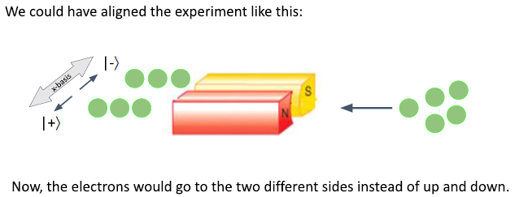

Qubit: |𝜓⟩ =|0⟩

measurement in x basis: collapses the quantum state of the qubit |𝜓⟩ to either

|+⟩ or |-⟩

|+⟩ : (|0⟩+|1⟩)/√2

|-⟩ : (|0⟩-|1⟩)/√2

### Quantum Entanglement

Quantum correlation between two (or more) objects where each of their states will depend on the state of the other.

Entangled state: |𝜓⟩ = √0.5|01⟩ + √0.5|10⟩

what if we only measure qubit A?

● If qubit A is 0 → the quantum state of qubit B is immediately set to |1⟩

● If qubit A is 1 → the quantum state of qubit B is immediately set to |0⟩

Bell states:

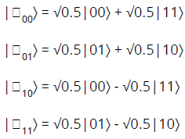

Applications:

● Quantum Teleportation

● Quantum Cryptography

● Superdense Coding

● Quantum speedups

# Week 13

## Quantum Mechanics 3 - Postulates of Quantum Mechanics

The six postulates of quantum mechanics

1. A quantum state is represented by its wavefunction |𝜓⟩: **Wavefunction postulate**
2. Classical observables → Operators in QM: **Operators postulate**
3. The only possible results of measuring an observable are the eigenvalues of its operator: **Observation postulate**
4. Probability of observing an eigenvalue = modulus square of inner product of corresponding eigenvector with |𝜓⟩: **Probability postulate**
5. After measurement, |𝜓⟩ is equal to the eigenvector corresponding to the observed eigenvalue: **Collapse postulate**
6. To evolve |𝜓⟩ in time, apply an operator to it: **Evolution postulate**

### String



• The string takes on specific shapes when it feely vibrates

• These shapes are called modes

• Modes are a result of confinement

• The string must be fixed at two ends

• These modes are eigenfunctions!

• At small scales, everything (electrons/atoms/ions…) can behave as a wave

• When they are confined, they show quantization, just like a string!

• We can use the modes as qubit states

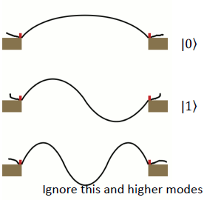

**First Postulate (Wavefunction):**

A quantum state is represented by a ket |𝜓⟩ in the state space.

Consequence: The superposition of any two quantum states is also a quantum state.

**Second Postulate (Operators):**

Classical observables are introduced into quantum mechanics using operators. Specifically, every observable (measurable property) of a physical system is described by an operator that acts on state kets.

Consequence: Relates observables that we can “measure” to the quantum world.

**Third Postulate (Observation):**

The result of a measurement of an observable with an operator Â will only ever be an eigenvalue of Â.

Consequence: Determines the possible outcomes of an observable measurement.

**Fourth Postulate (Probability):**

When a measurement of an observable with operator Â is made on a generic state |𝜓⟩, the probability of obtaining a certain eigenvalue a i is given by the square of the inner product of |𝜓⟩ with the corresponding eigenstate: |⟨ai|𝜓⟩|2

Consequence: Gives the probabilities of measuring the different outcomes of an observable measurement.

**Fifth Postulate (Collapse):**

Immediately after the measurement of an observable A with a value an, the state of the system is the normalized eigenstate |an⟩

Consequence: The superposition collapses into one state after the measurement.

**Sixth Postulate (Evolution):**

Quantum states generally change (evolve) with time. This time evolution preserves the normalization of the state. The time evolution of the state of a quantum system is described by:

|𝜓(t)⟩ = Û(t)|𝜓(0)⟩, for some unitary operator Û

Consequence: The evolution of the quantum state with time is reversible.

**How do the postulates relate to quantum computing?**

● Give us instructions on how to operate the quantum hardware

● Tells us what happens after we measure our quantum circuit

● Allow us to calculate the probability of getting the right answer based on the set of gates that we run in our algorithm

**Measuring Spin**

The only possible results of measuring an observable are the eigenvalues of its operator: Observation postulate

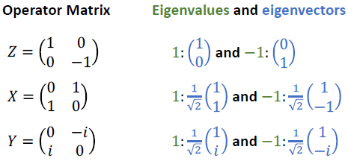

**Problem 1**: What are the possible outcomes of measuring spin along the z-axis?

Solution: 1 and -1, i.e. eigenvalues

**Problem 2**: The result of a measurement of spin along the z-axis is -1. What is the wavefunction of the electron immediately after the measurement?

Solution: Down 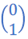, i.e. eigenvector

**Problem 3**: What is the probability of the result of measuring the spin of the electron in state|𝜓⟩ being +1? What is the probability of -1?

Solution: |0.71|2 = 0.5

**Key Takeaways**

* When a system that shows wave-like behavior is confined, the wave modes get quantized
* At the scale of electrons/atoms/ions, everything shows wave-like behavior. Therefore, everything shows quantization when it is confined!
* The postulates of quantum mechanics are the rules that quantum systems are observed to follow

# Week 14

## The Qubit & Bloch Sphere

Qubit

* Building block of quantum computers
* A two-level system
* Can be in a superposition of two values

Euler’s Formula and Complex Exponentials

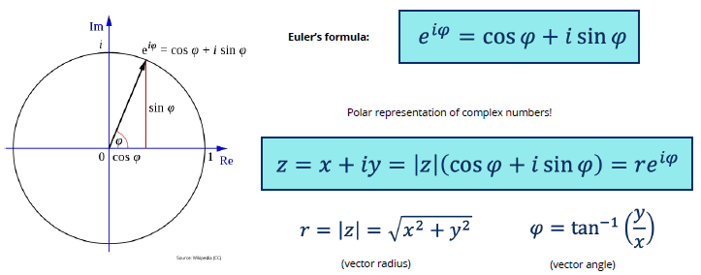

### Phase

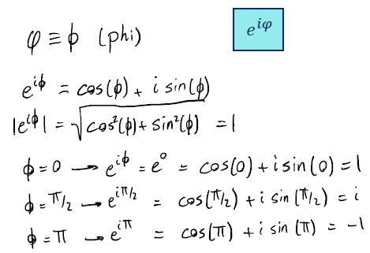

In quantum mechanics global phase has NO physical significance and NO effect, so it can be ignored.

𝑒i𝜓|𝜓⟩ →|𝜓⟩

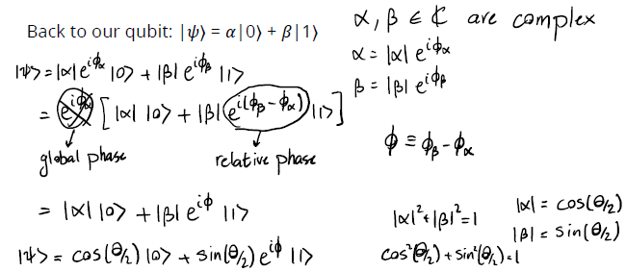

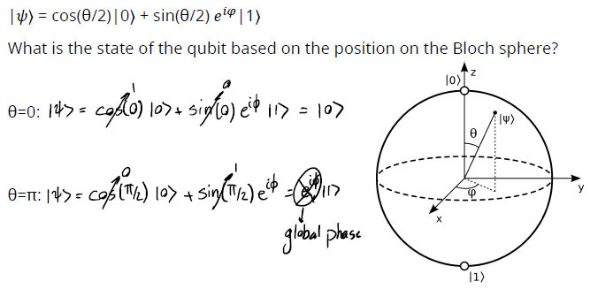

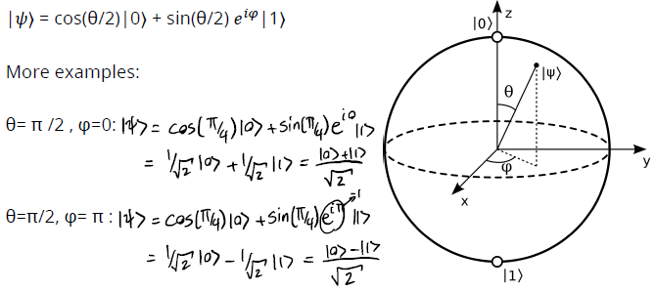

### Quantum gates

* Maps one the quantum state to another quantum state
* Moves a point on the Bloch Sphere to another point
* We can represent them with matrices

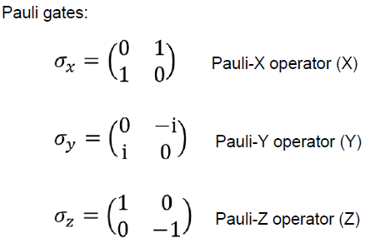

All Pauli operators use pi (180) degrees.

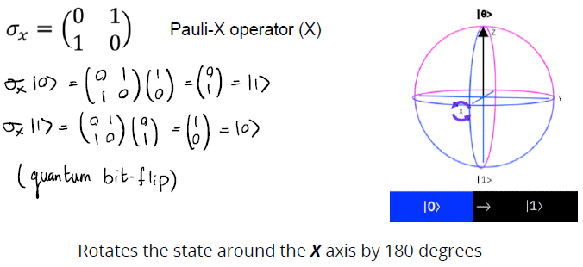

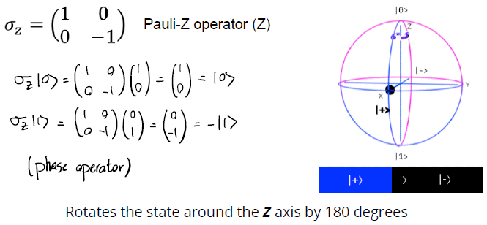

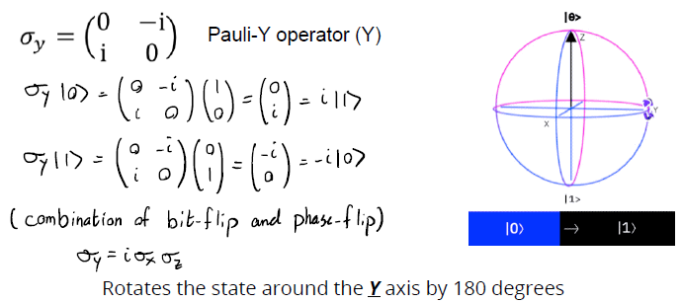

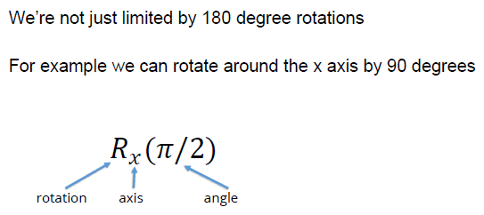

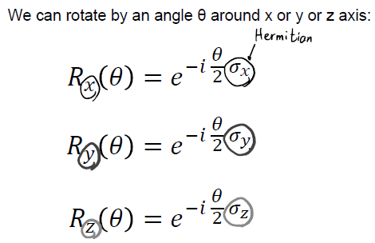

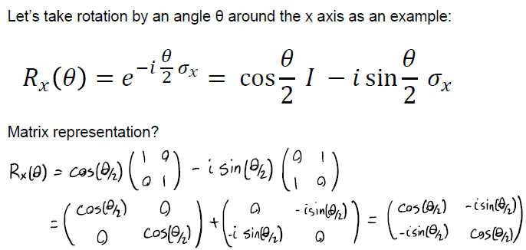

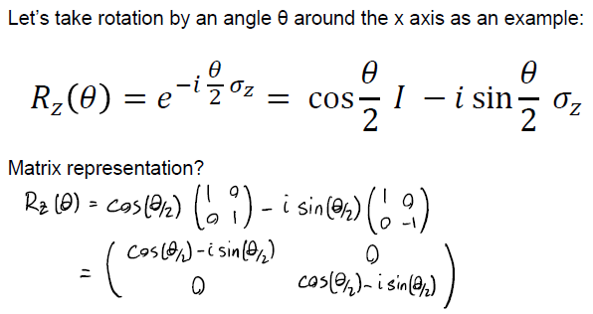

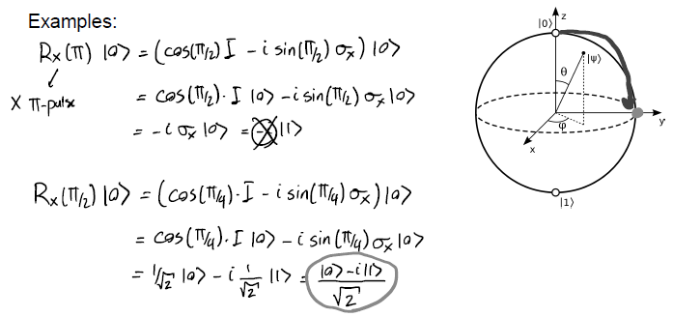

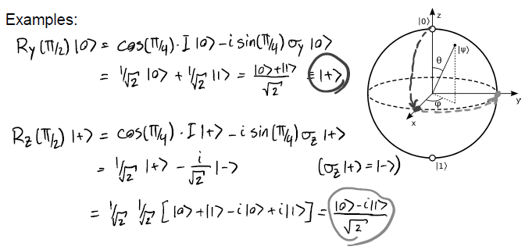

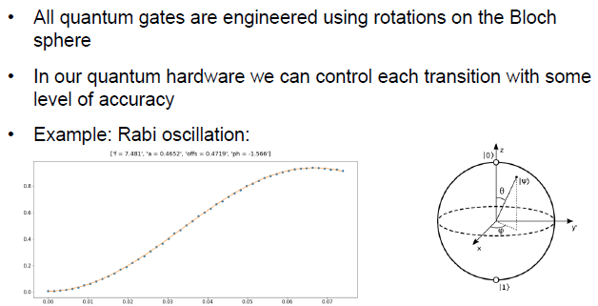

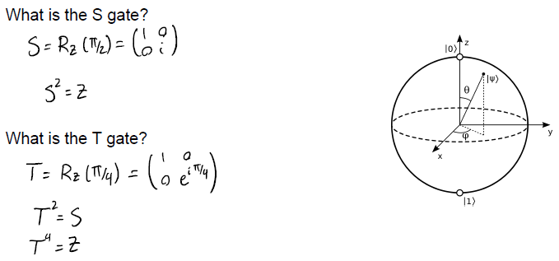

### Bloch Sphere

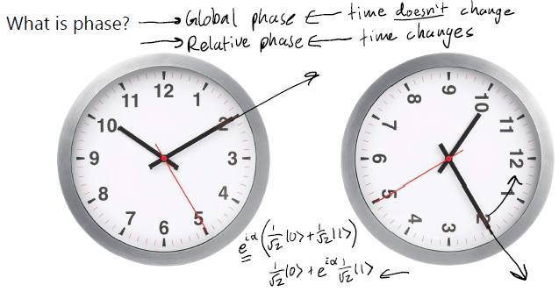

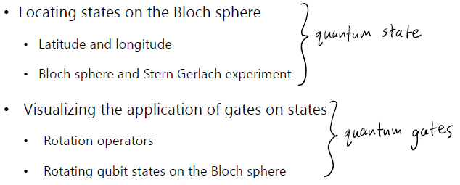

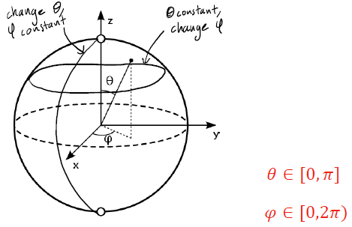

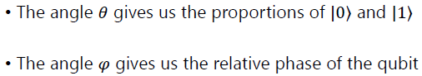

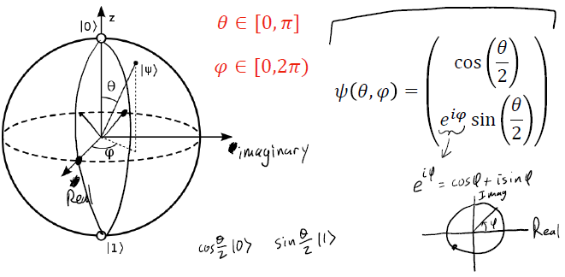

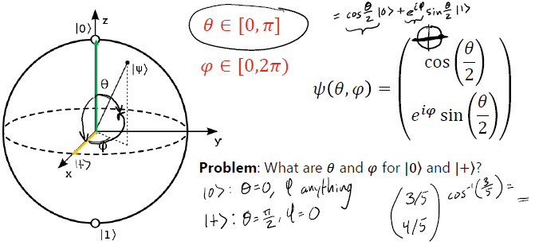

### X-Rotation Gate

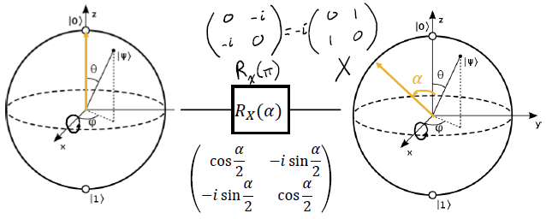

### Y-Rotation Gate

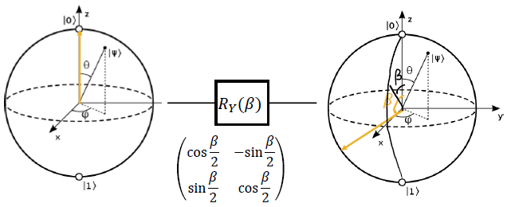

### Z-Rotation Gate

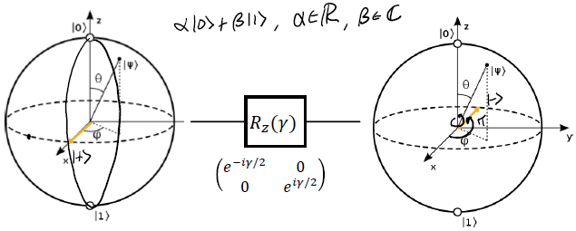

### Example

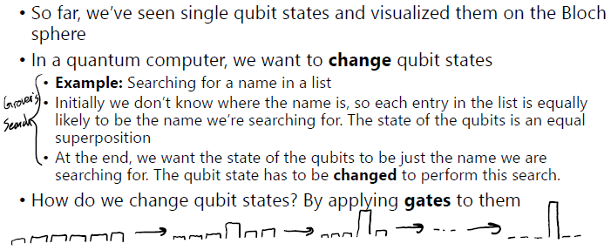

# Week 15

## The Quantum Circuit Model

Classical vs Quantum Circuits

States

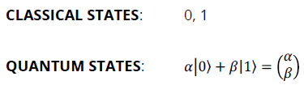

Gates

We can manipulate the state of a single qubit by rotating it in the Bloch sphere. Thus, quantum operations (matrices) are the gates of quantum computation.

Measurements

Unlike deterministic classical measurements, quantum measurements are probabilistic.

Although you can measure along multiple axes, we usually set the z-axis as our measurement axis in our reference frame.

If you want to know the underlying distribution of a quantum state, you need to create the state several times and perform repeated measurements.

Week 16

Qiskit

### Simulating Quantum Circuits

Can simulate quantum systems using classical computers.

Limited to ~50 qubits

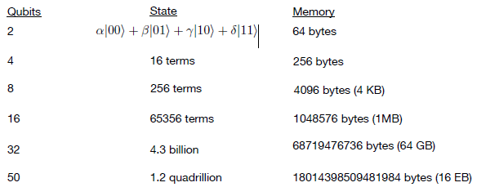

IBM Quantum Experience ( IQX )

The IQX is a cloud-based platform for using quantum computers. You can program quantum computers using qiskit in a Jupyter Notebook environment or explore and execute circuits graphically using the circuit Composer.

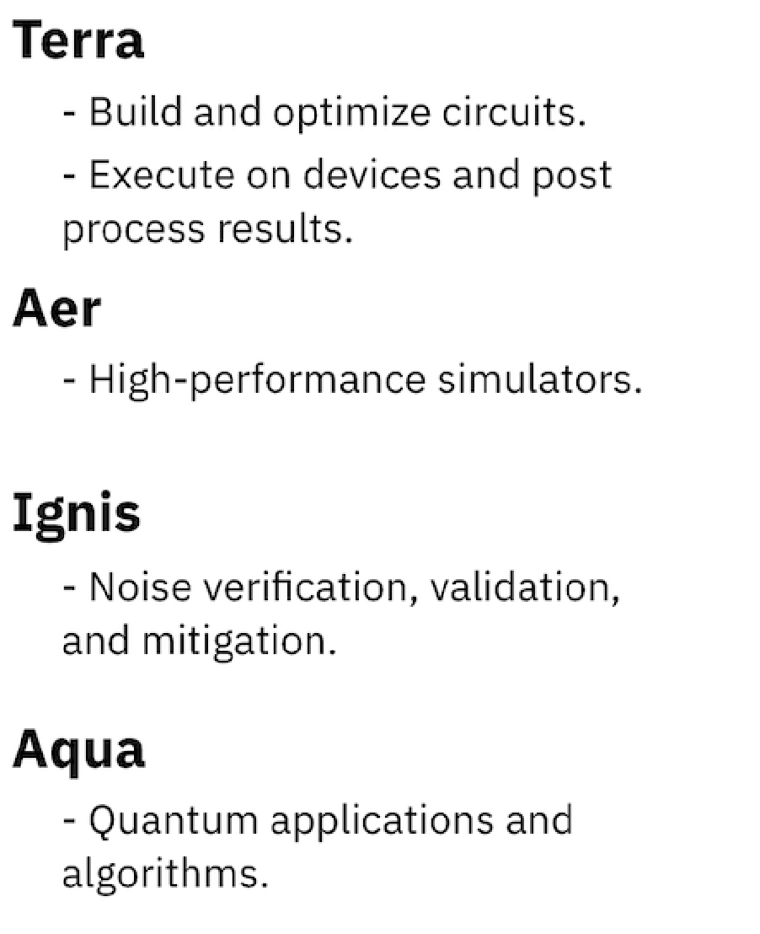

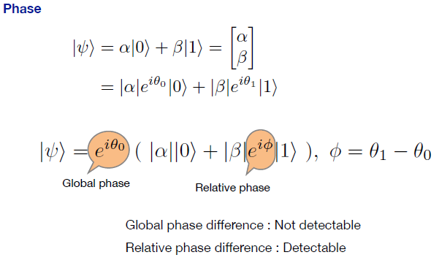

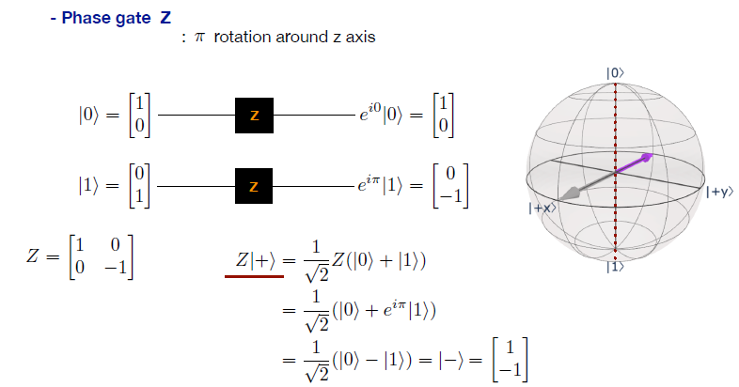

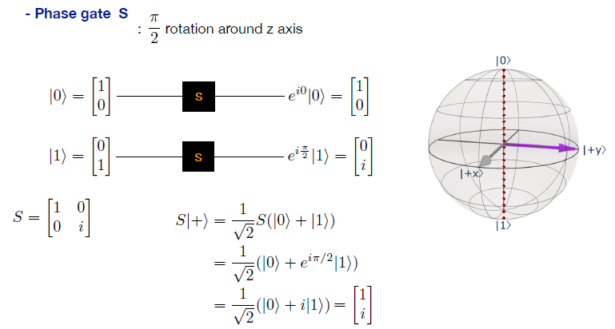

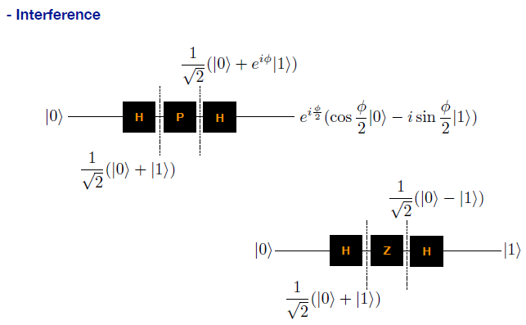

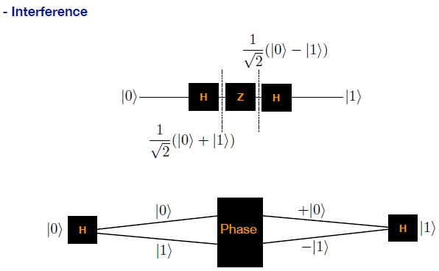

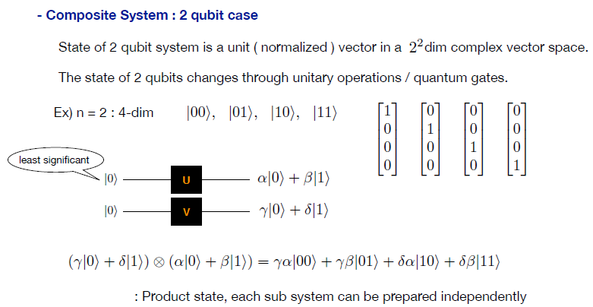

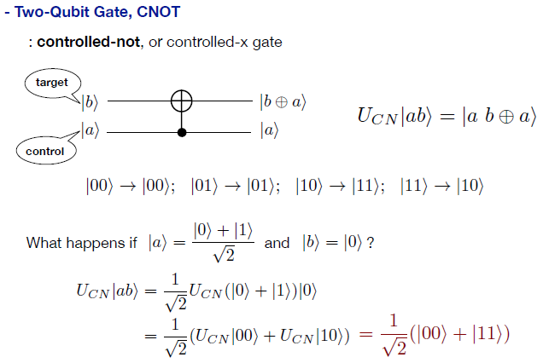

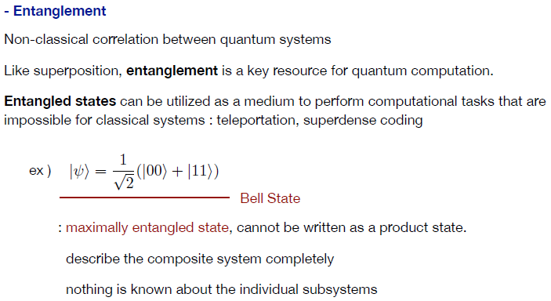

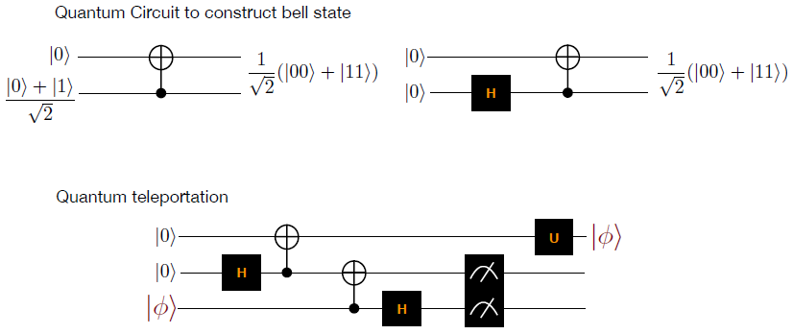

Week 17

Quantum Circuit Math

### Single-Qubit Circuit Math

Order matters:



Measurement:

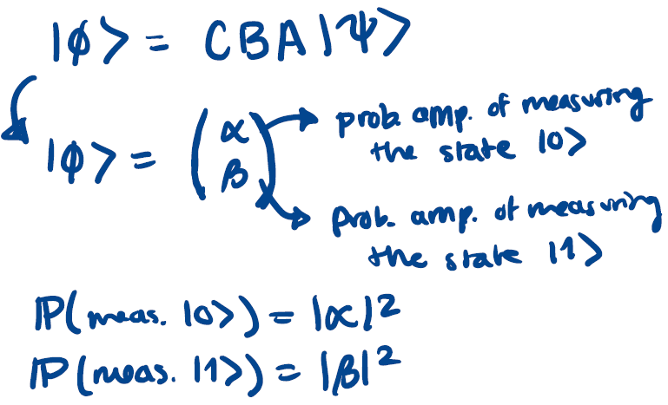

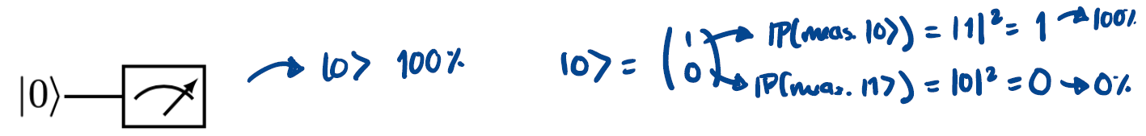

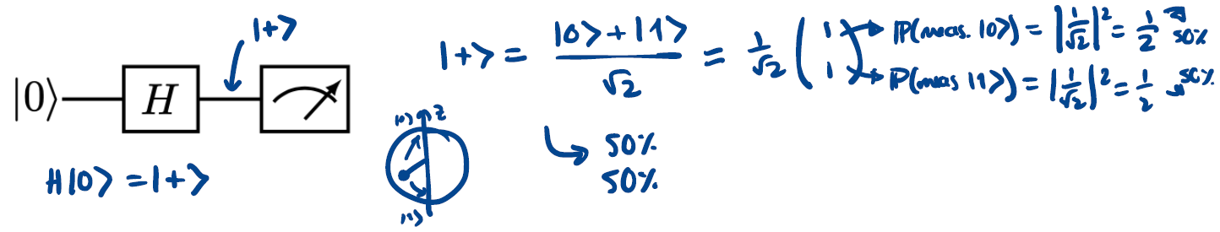

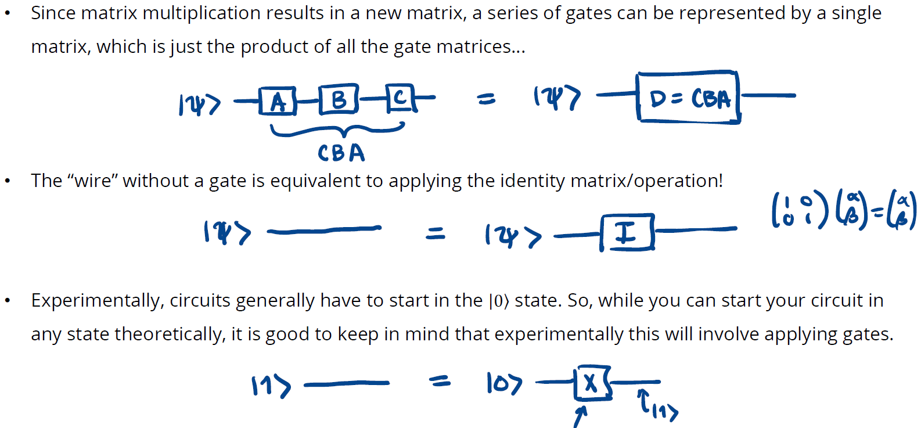

### Multi-Qubit Circuit Math

Method #1: Individually solve each of the n single-qubit circuits.

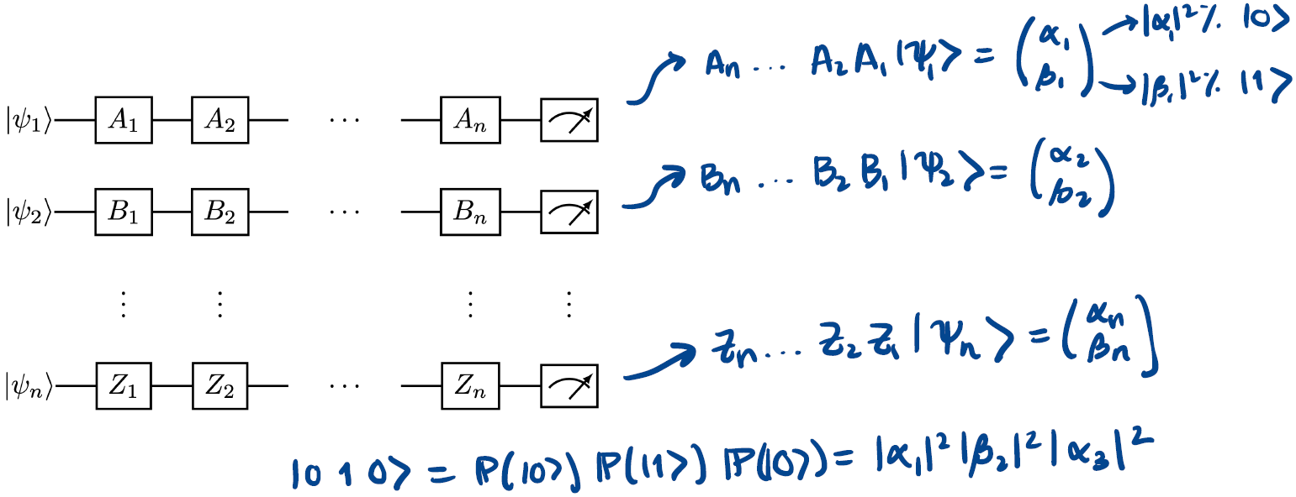

Method #2: Simultaneously solve all n single-qubit circuits.

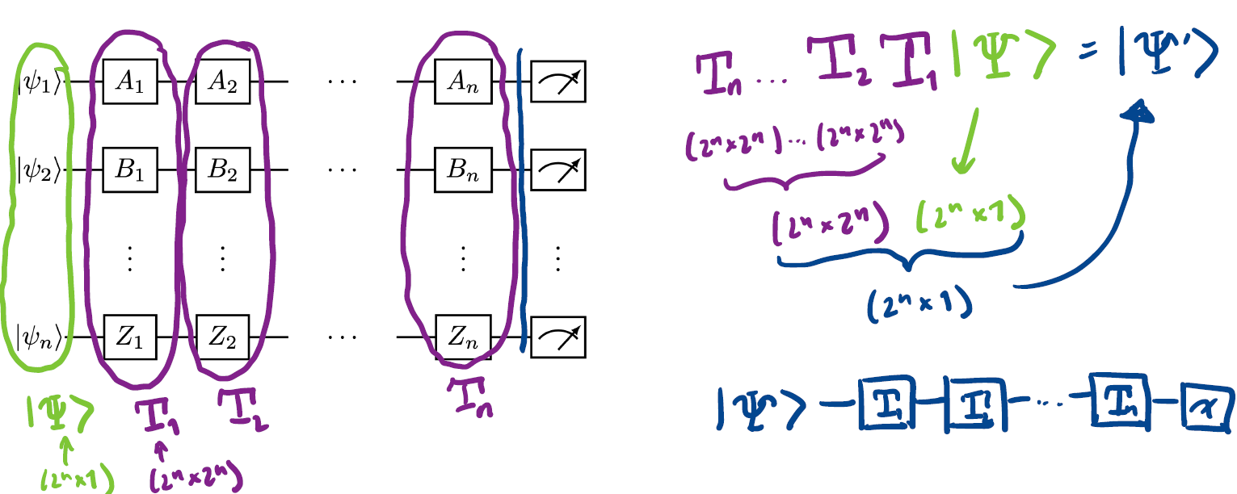

### Tensor Product

Mathematically, a quantum bit string is simply a tensor product of qubits!

Mathematically, gates acting on different qubits are a tensor product of all the gates!

A tensor is essentially an n-dimensional vector… In quantum computing, we care about vectors (states) and matrices (gates), which are 1-D and 2-D tensors!

If A is an (nxm) matrix and B is a (pxq) matrix, their tensor product is the (np x mq) matrix:

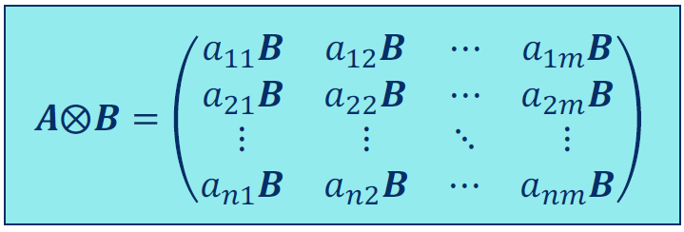

n qubits are represented mathematically by a vector of length 2n.

If we want to calculate how a set of quantum gates will affect our multi-qubit state, we will need to take

the tensor product of the gate matrices.

Note that wherever there is not a gate, we must insert an identity matrix.

n single qubit gates on different wires are represented mathematically by a matrix of dimension (2n × 2n).

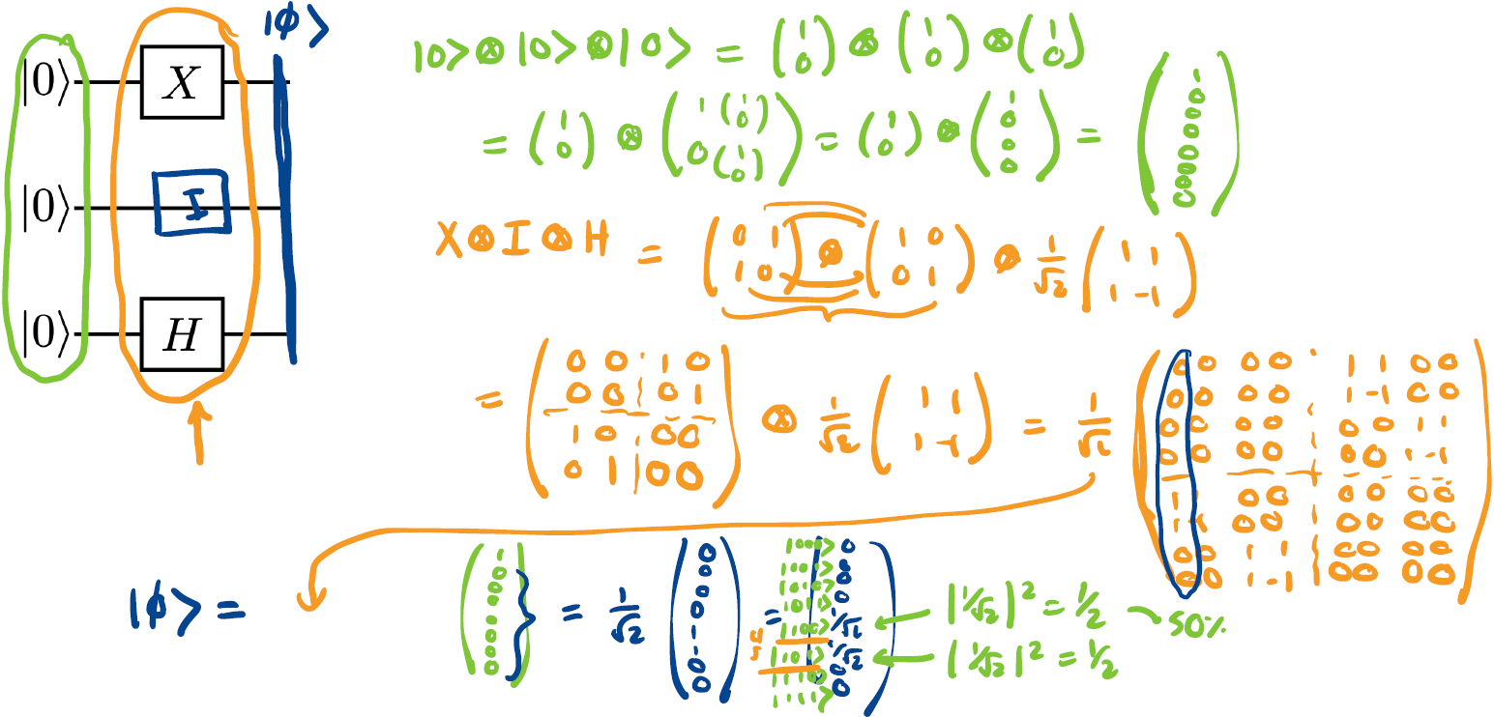

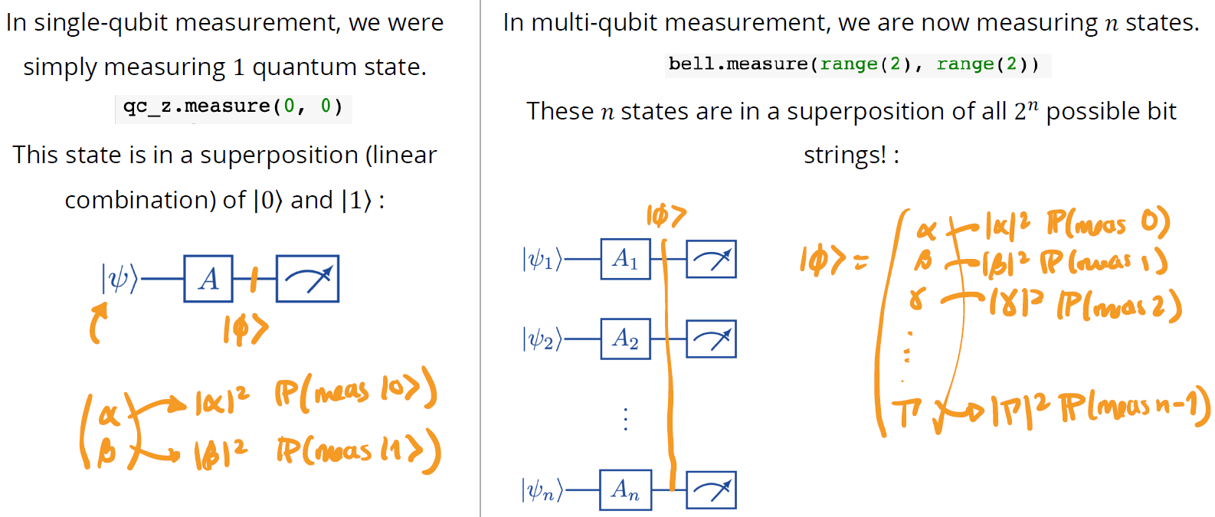

2-qubit circuit measurement:

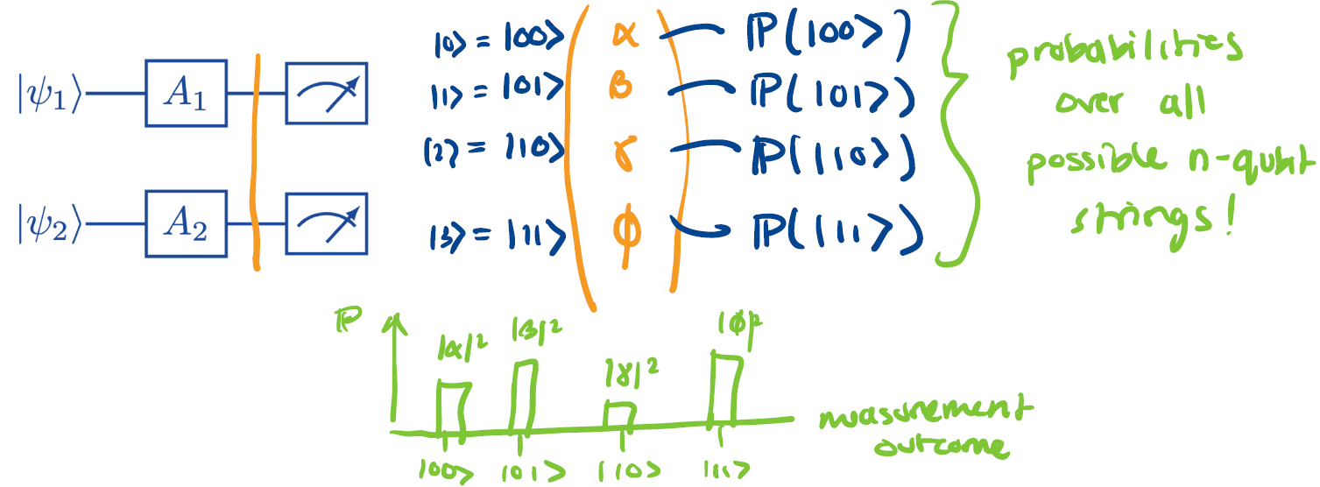

Equal likelihood of measuring every possible quantum bitstring:

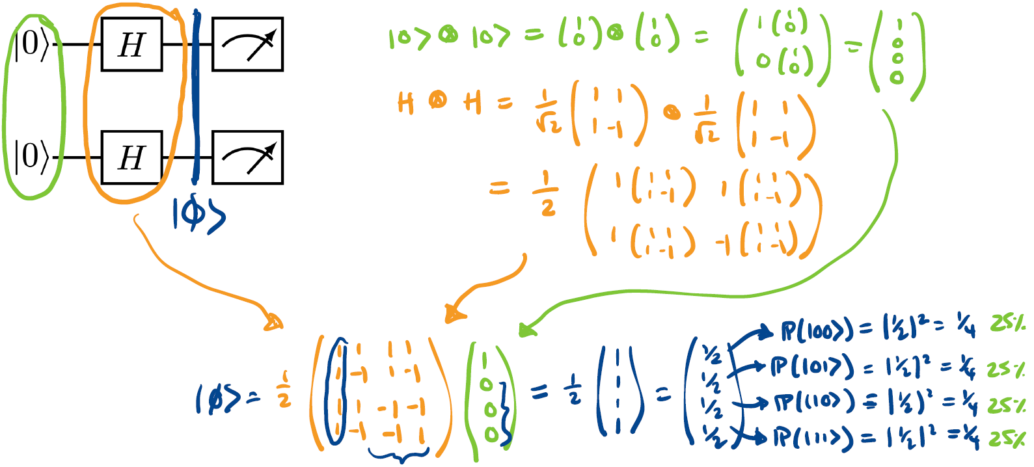

Bell’s States:

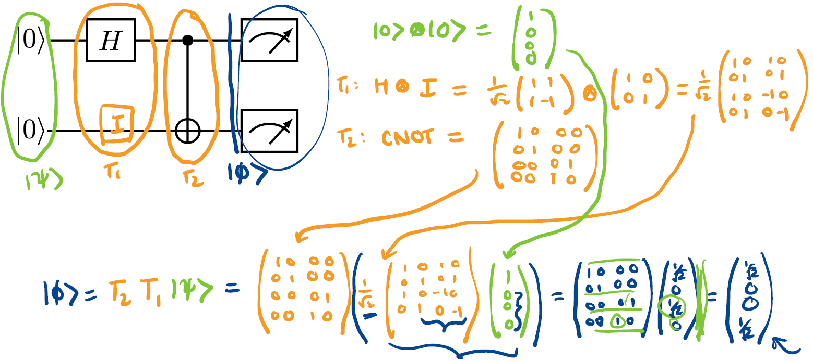

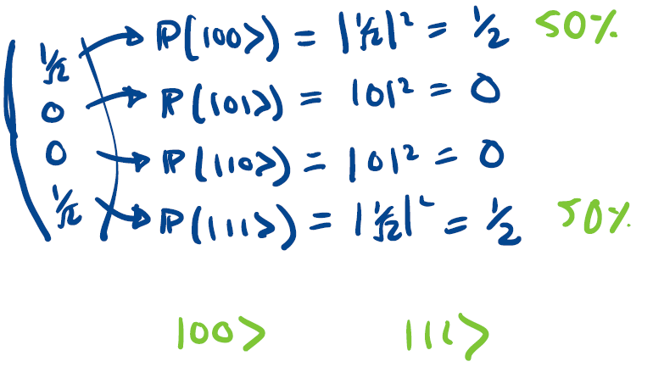

• Tensor products are used to form the statevectors for multi qubit states. Tensor products essentially tell you all the possible combinations of the vectors.

• QASM simulator requires classical bits and measurements to be present in the circuit, unlike statevector simulator.

• To make a phi(-) Bell state, we first use an H gate followed by a Z gate to flip the sign of the |1> part of the superposition, before applying the CNOT gate.

Week 18

Superdense Coding and Quantum Teleportation

### Key Ideas

**Superdense Coding**: Transmit two bits of classical information with one qubit.

**Quantum Teleportation**: Transmit one qubit with two bits of classical information.

Assuming an entangled bell pair has already been split between the sender and receiver

### Superdense Coding

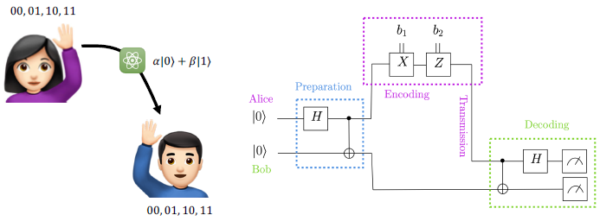

### Superdense Coding Protocol

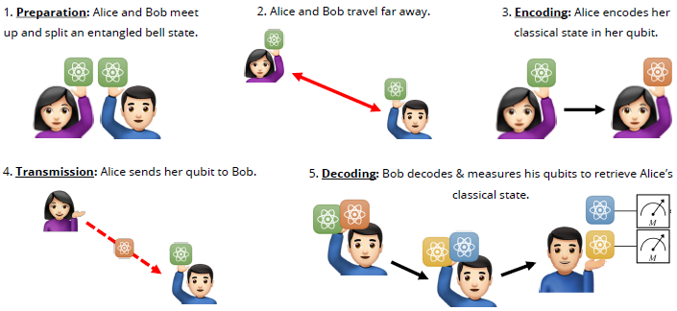

### Superdense Coding Preparation

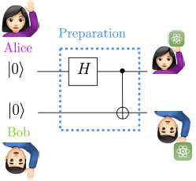

### Superdense Coding Encoding

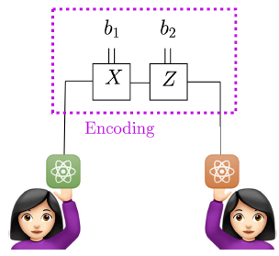 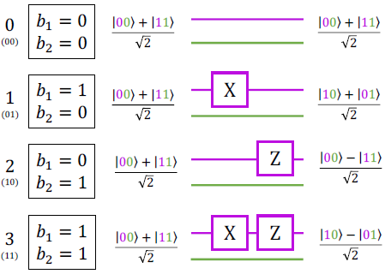

A Bell measurement is a joint quantum mechanical measurement of 2 qubits, that determines which of the 4 Bell states the qubits are in.

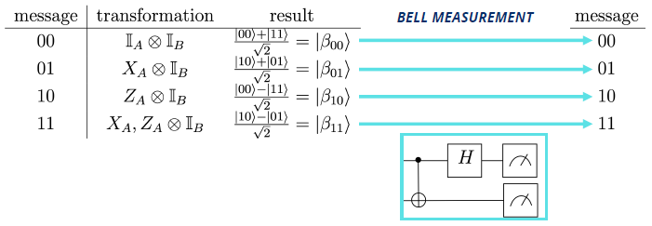

### Superdense Coding Transmission

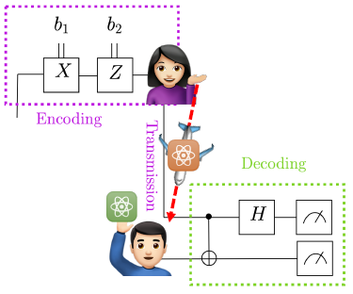

### Superdense Coding Decoding

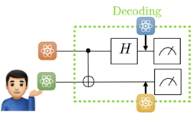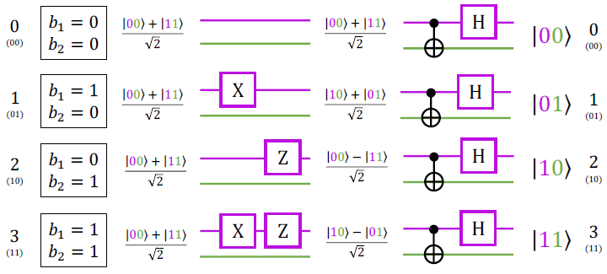

### Quantum Teleportation

1. Quantum teleportation requires that an entangled bell state be split between the sending and receiving destinations.
2. Since quantum teleportation requires measuring the bell state, each time you want to perform teleportation you have to share a new bell state.
3. Quantum teleportation is not instantaneous. It requires classical communication (i.e. a phone call or email) between the sender and receiver.
4. Quantum teleportation is meant for sending one qubit at a time, not a full person.

### Backstory

1. Two scientists, Alice and Bob, met in the United States to create a Bell state (with 2 photons).
2. However, Alice had to go back to her lab in Australia and Bob to his lab in Brazil. Each took one of the entangled photons back with them.
3. Back to work in her Australian lab, Alice generated all kinds of exotic quantum states. One day, she managed to create the extremely rare single-qubit state |𝜓⟩ = 𝛼|0⟩ + 𝛽|1⟩.
4. Meanwhile, in his Brazilian lab, Bob discovered he needed rare qubit state |𝜓⟩ = 𝛼|0⟩ + 𝛽|1⟩ for an important experiment. So, he asked Alice to teleport |𝜓⟩ using their shared Bell states.
5. This is the quantum circuit they will use to quantum teleport state |𝜓⟩.

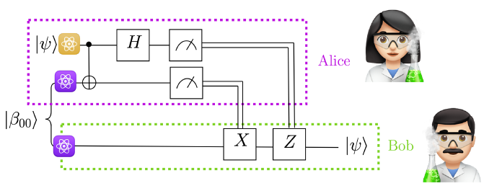

### Quantum Teleportation Protocol

**Step 0: Input**

To teleport a quantum state, Alice and Bob only need access to an entangled bell pair and a classical communication channel by which they can transmit 2 classical bits of information.

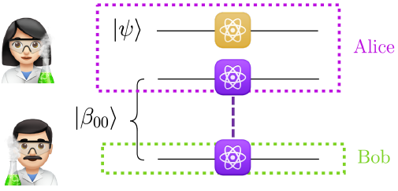

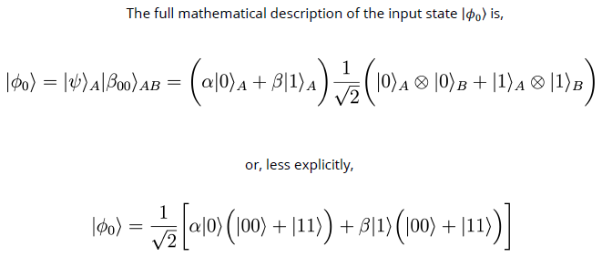

**Step 1: Entangling Circuit**

In the first step of the quantum teleportation procedure, Alice performs a CNOT and Hadamard, to entangle her exotic quantum state |𝜓⟩, with her portion of the shared Bell state, |𝛽00⟩A.

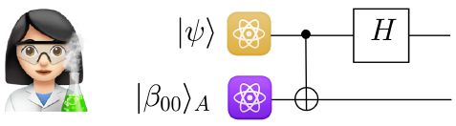

Initial State: 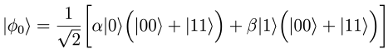

After CNOT: 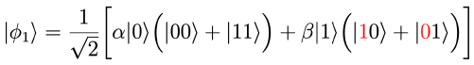

After Hadamard: 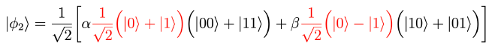

After Regrouping: 

**Step 2: Measurement**

Now, Alice performs a measurement on her qubits, causing them to collapse to classical bit states.



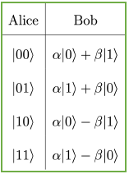

If Alice measures the state |00⟩, Bob’s qubit is guaranteed to be in the desired state |𝜓⟩ = 𝛼|0⟩ + 𝛽|1⟩.

What quantum operations does Bob need to perform on the following states to transform each to the desired |𝜓⟩ = 𝛼|0⟩ + 𝛽|1⟩ state?

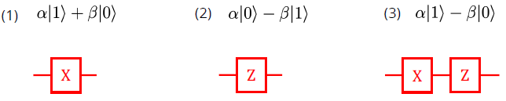

**Step 3: Classical Transmission**

For Bob to correct his qubit state to |𝜓⟩, he needs to know the measurement results of Alice’s qubits. Thus, Alice must transmit her measurement results via a classical communication channel.

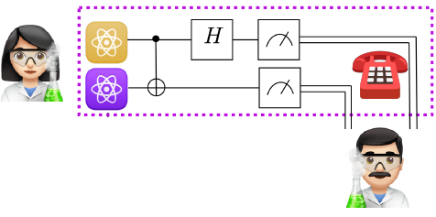

**Step 4: Receiver Corrections**

Dependent on the classical bit states communicated by Alice, Bob will need to perform two quantum operations from the set {I, X, Z}, to correct his qubit to state |𝜓⟩.

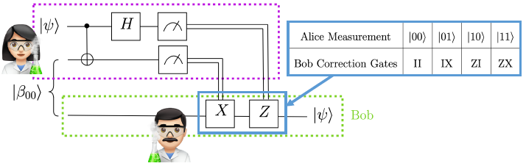

Week 19

Quantum Key Distribution (BB84)

### Quantum Protocols

The word protocol can have different meanings depending on the context… In computer science, a protocol is a set of rules or procedures for transmitting data between 2 entities. For example, the Internet Protocol Suite (frequently known as TCP/IP) is a set of communication protocols used in the Internet and similar computer networks. It specifies how data should be packetized, addressed, transmitted, routed, and received.

Quantum protocols are also a set of rules or procedures for transmitting data between 2 entities. However, quantum protocols leverage quantum information! A good quantum protocol will achieve some sort of advantage to classical protocols.

Usually, quantum protocols transmit data more efficiently or more securely than classical protocols! We already saw two examples of efficient quantum protocols last class: Superdense Coding and Quantum Teleportation.

### Quantum Cryptography

Cryptography is the practice/study of techniques for secure communication in the presence of third-party adversaries. It is about constructing and analyzing protocols that prevent third parties or the public from reading private messages.

Post-quantum cryptography is the field devoted to studying algorithms robust to attack by a quantum computer.

Quantum cryptography is the field of study dedicated to exploiting quantum mechanics to perform cryptographic tasks.

### Classical Key Distribution

Encryption is the process of encoding/scrambling a message so that it can only be read by desired parties.

Decryption is the process of converting the encrypted message back into a readable form.

A key is simply a long string of 0s and 1s, which can be used to encrypt and decrypt a message.

There are two parties (Alice and Bob) who are trying to exchange private messages. However, they are aware that an eavesdropper (Eve) is trying to listen in on their conversation for malicious purposes. To protect their message, Alice and Bob share a private key to encrypt/decrypt their messages. In classical symmetric key cryptography, the main challenge is securely sharing the private key between Alice and Bob.

### BB84 QKD Protocol

BB84 is a quantum key distribution protocol that was invented by Charles Bennett and Gilles Brassard in 1984. It uses quantum mechanics to distribute a symmetric key.

Alice has generated a key, which she wants to share with Bob. Alice and Bob suspect that Eve has tapped the quantum channel and is intercepting photons on fiber optic lines (polarized light).

Main idea: Send key, know if someone intercepted the key, if so throw away and try again, otherwise use key. The BB84 protocol does not prevent Eve from intercepting the key. Instead, the BB84 protocol allows Alice and Bob to statistically deduce if Eve has tapped the communication channel and is intercepting their key. If their quantum communication channel is not secure, Bob should disregard the transmitted key. Alice and Bob will need to find another quantum channel and try again. Once Alice and Bob are confident that they have securely transmitted their key, they can use a typical encryption scheme with the key to transmit their secret message.

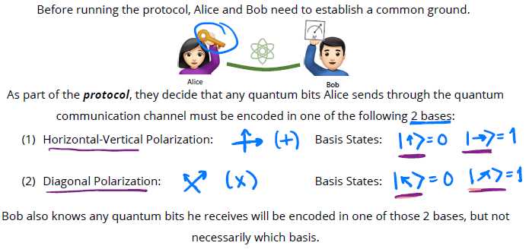

1. SELECT ENCODING: Alice randomly selects a basis ( × or + ) to encode each bit.

2. SELECT MEASUREMENT: Bob randomly selects a basis ( × or + ) to measure each bit.

3. Q. ENCODE: Alice creates the quantum states, encoded in the selected bases.

4. Q. SEND: Alice sends Bob the encoded states, via the quantum channel.

5. Q. MEASURE: Bob measures all the quantum states in his pre-selected measurement bases.

6. C. ANNOUNCE BASIS: Alice announces which basis she used to encode each bit, via the classical channel.

7. C. REVEAL SOME BITS: Alice reveals some of the bits she sent.

8. ANALYSIS: Bob performs analysis to determine if the message was intercepted by Eve.

-> If so, Alice and Bob should move to a new quantum communication channel and try again; back to (1)

-> If not, the key was securely transmitted!

Alice and Bob can now communicate via a channel encrypted using their quantum-distributed key.

Week 20

Introduction to Quantum Algorithms

### Algorithms

An algorithm is a set of instructions or rules that, especially if given to a computer, will help to calculate an answer to a problem. We have two key goals in designing an algorithm:

1. Accuracy: Solve the problem correctly

2. Efficiency: Solve the problem as quickly as possible

Naïve Runtime Issues:

• Runtime is hardware dependent

• Runtime depends on the input difficulty

• Runtime depends on the input size

Computer scientists have developed a good metric for characterizing algorithmic efficiency, which addresses all these issues, known as Big-O notation.

Big-O Solution:

• Big-O reports # of operations, not actual runtime

• Big-O characterizes the worst-case performance

• Big-O is expressed as function of input size

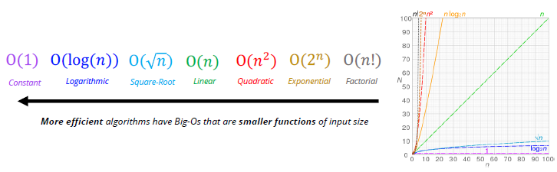

Linear Search: O(𝑛)

Binary Search: O(log(𝑛))

### Quantum Algorithms

All quantum algorithms boil down to quantum circuits, but not every quantum circuit is a useful quantum algorithm.

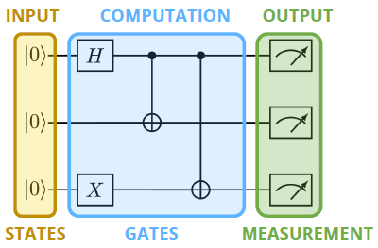

Quantum algorithms need to strategically leverage our 3 quantum resources: Superposition, Entanglement, and Quantum Interference to outperform their classical counterparts.

It turns out that designing such algorithms is challenging. You can’t just throw together any quantum circuit and expect quantum advantage. Demonstrating that a quantum device can solve a problem significantly faster than any classical device is known as quantum advantage (traditionally quantum supremacy).

Currently, there exist only a few core quantum algorithms which offer big computational advantages. We are going to spend the rest of looking at these core algorithms and what makes them interesting. Since these algorithms are complicated, we will also focus a key-technical take-away.

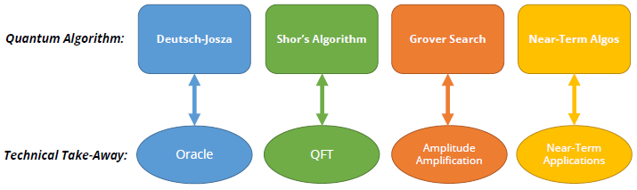

### Deutsch-Jozsa Algorithm

Problem: The algorithm is not practically useful - it solves a “toy problem”.

Why do we care?: It was the first theoretical demonstration of quantum advantage!

Classical Efficiency: O(2n)

Quantum Efficiency: O(1)

Speedup: Exponential

Technical Take-Away: Deutsch-Jozsa uses an oracle

Quantum Circuit:

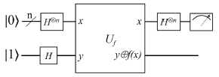

### Oracle

The notion of an oracle comes from complexity theory. You can think of an oracle as a genie that grants you a computational wish. There are two different types of wishes the oracle genie can grant:

(1) Decision Problem: given a problem (specified by a bit-string), the genie will tell you whether the answer is “NO” (0) or “YES” (1)

(2) Function Problem: given an input, bit-string 𝑥, the genie will calculate the output, bit-string 𝑓(𝑥), for some unknown but desired function 𝑓

Key Idea: You give the genie (oracle) an input, and he performs some computation. You do not know or understand his computation (it’s a black box!), but he always returns the correct output.

### Shor’s Algorithm

Problem: Factor large integers (period finding).

Why do we care?: RSA encryption is only secure if large integers are hard to factor!

Classical Efficiency: ~O(𝑛1.9)

Quantum Efficiency: ~O(log(𝑛)3)

Speedup: Super-Polynomial

Technical Take-Away: Shor’s algorithm uses the QFT

Quantum Circuit:

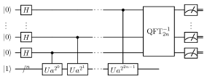

### Fourier Transform

In 1822, French mathematician Joseph Fourier showed that any function can be represented (or very-well approximated) with a linear combination of trig-functions with varying frequencies. This led him to develop one of the most important equations in science and engineering: the Fourier Transform (FT). It provides a mapping from the time domain to the frequency domain. This enables us to find the most prominent frequencies in our signal.

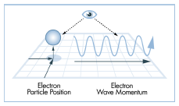

The momentum-position relationship in quantum mechanics is mathematically governed by the FT.

In 1994, Don Coppersmith developed the Quantum Fourier Transform (QFT), which encodes frequency information in the phase of our quantum states. At the end of the day, however, the FT and QFT are just performing a change of basis. In fact, for a single qubit, the Hadamard is the QFT. It’s just a change of basis from the Z-basis to the X-basis.

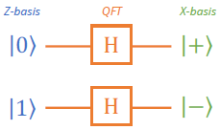

Shor cleverly realized that the problem of integer factorization is a problem of period-finding, which can be solved with a quantum subroutine known as phase estimation, that leverages the QFT.



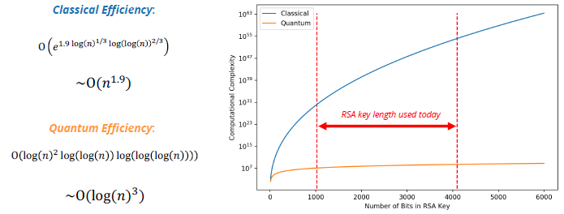

### Amplitude Amplification and Grover Search

Problem: Searching assuming no data structure

Why do we care?: Search is everywhere – i.e. databases

Classical Efficiency: O(𝑛)

Quantum Efficiency: O(𝑛1/2)

Speedup: Quadratic

Technical Take-Away: Grover’s algorithm uses amplitude amplification

Quantum Circuit:

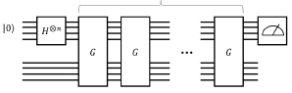

Grover search introduced a technique later formalized as amplitude amplification. Through clever circuit design (using an oracle), you can amplify the probability of measuring the bit-string corresponding to the item you are searching for. The goal is to find the index of 𝑤 in your list:

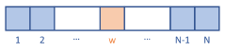

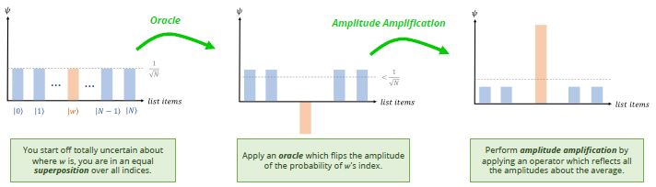

### Near-Term Hybrid Algorithms

“Near-Term”: make use of the small noisy quantum devices we will have access to in the near-term

“Hybrid”: since the quantum devices are limited, let’s have them work alongside classical devices

Current near-term hybrid quantum algorithms research is primarily focused on variational quantum circuits.

Key Idea: The gates in a quantum circuit correspond to rotations, so we can parametrize the angles of rotation. A classical computer can then be used to optimize the values of these parameters, to design a good quantum circuit.

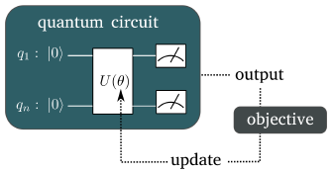

The Variational Quantum Eigensolver (VQE) algorithm is already being used to solve several problems in quantum chemistry and material science, such as finding the ground state energy of a molecular system.

In machine learning, typically data is not linearly separable, and it is hard to make a function to perform classification. However, often we can apply functions to our data to make it linearly separable. This is known as a feature mapping.

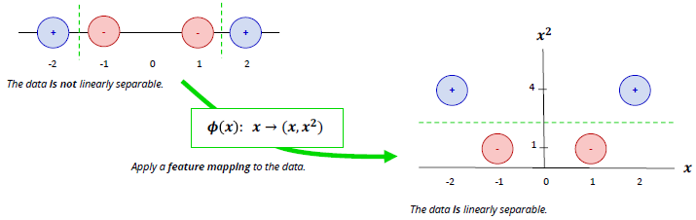

Computationally finding an optimal feature mapping for a dataset is hard. Variational quantum algorithms have been proposed to learn powerful feature mappings.

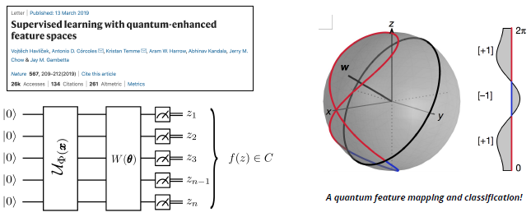

### Summary

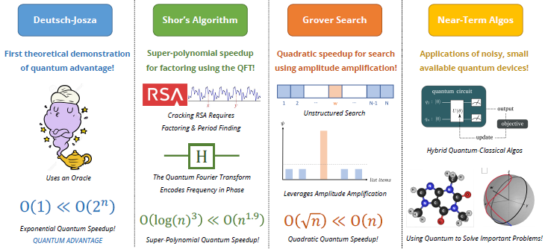

### Lab

We have a function 𝑓(𝑥), which takes as input a binary variable 𝑥. The function also returns a binary number for each input value of 𝑥.

• We have four possible forms of 𝑓(𝑥):

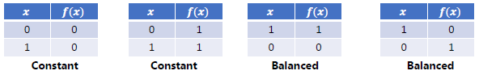

• The problem is can you figure out if a given function 𝑓(𝑥) is constant or balanced? How many times do you need to test the function to find out the answer?

How would you solve this problem classically?

• You would have to test out the function with inputs (𝑥 values) of 0 and 1.

• You need two steps.

We want to make a quantum circuit to solve this problem.

• We’ll want a way to implement 𝑓(𝑥) in a quantum circuit.

• All quantum gates must be reversible. Is 𝑓(𝑥) reversible?

• Problem: Quantum gates need to be reversible. 𝑓(𝑥) is not reversible.

• Solution: Oracles! The function is reframed as a genie that will answer questions based on the inputs you give it.

• Since 𝑓(𝑥) is not reversible in general, we need to make a reversible version of it for our quantum algorithm.

• This reversible version is the Deutsch-Josza oracle 𝑼𝒇.

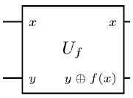

This oracle is reversible because 𝑦⨁𝑓(𝑥)⨁𝑓(𝑥) = 𝑦

The oracle uses an XOR operation that can be implemented with a CNOT quantum gates.

• Using the oracle, the Deutsch-Josza algorithm lets you solve the problem in one step.

• The algorithm uses superposition and interference to solve the problem in one step.

The D-J algorithm:

1. Initiate a quantum circuit of two qubits, x and y

2. Apply an X gate to y

3. Apply H gates to both x and y for superposition

4. Apply the oracle to x and y

5. Apply H gates to both x and y for interference

6. Measure x. If the result is 0, the oracle is constant. If it is 1, the oracle is balanced.

• For this simple 1-bit input case, the classical algorithm uses 2 steps, and the D J algorithm uses 1.

• For an n-bit input, the classical algorithm is 𝑂(2𝑛), whereas the D J algorithm is still 𝑂(1).

• Big O notation is a way to characterize how many computations an algorithm makes in the worst case.

• Linear search has a complexity of 𝑂(𝑁)

• The Deutsch-Josza algorithm uses superposition and interference to show an exponential speedup over the classical algorithm to solve the toy “Goldilocks” problem.

Week 21

Quantum Search Algorithm

### Grover Search Algorithm

• Goal: Search an unsorted list of length N for a specific element

• Assumption: Already know what we’re looking for, we just don’t know where it is

Classical search algorithm: O(N)

Quantum search algorithm: O(N1/2)

What makes Grover’s “quantum”?

Reminder from the beginning of the semester: Qubits behave as particles and waves.

We can put all these choices into superposition because of the wave properties of qubits. Since they’re waves, they can interfere with each other. Incorrect solutions get destructively interfered. Correct solutions get constructively interfered.

Grover’s algorithm steps:

STEP 1. Equal superposition: Start by assigning equal probability to every cell being the right answer.

STEP 2. Amplitude amplification: Use quantum interference to transform the superposition so the correct cell has a significantly higher probability.

STEP 3. Measurement: Measure the state, with high probability the result is the right cell.

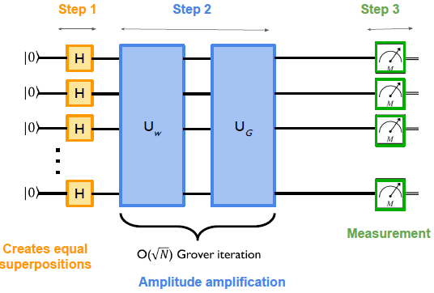

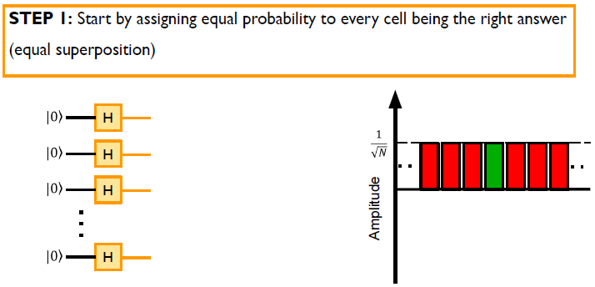

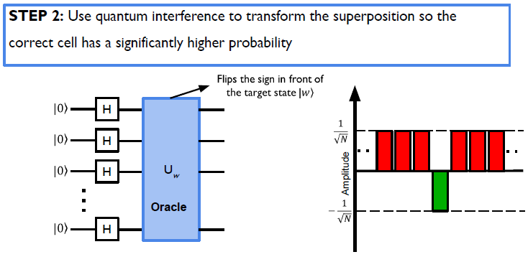

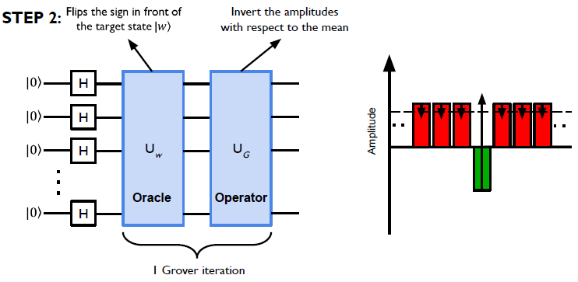

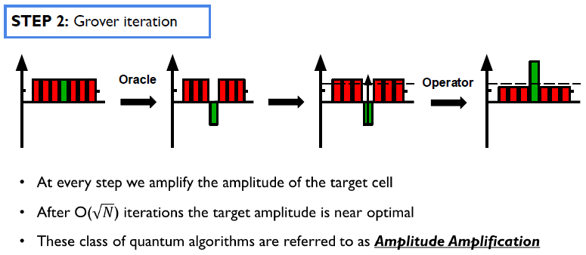

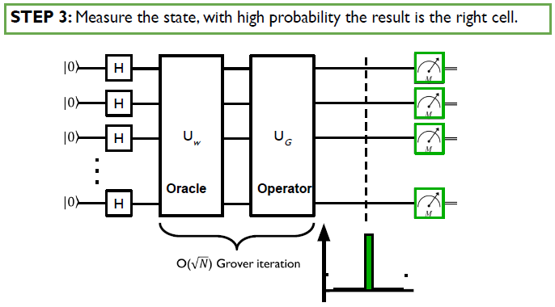

Applications:

• Speeding up database search

• Speeding up optimal scheduling

• Speeding up mean and median estimation

• Speeding up element counting

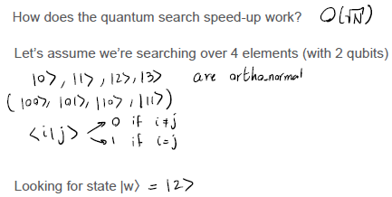

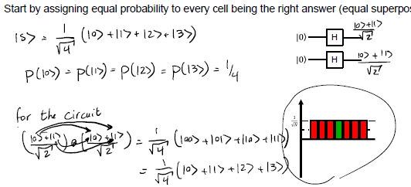

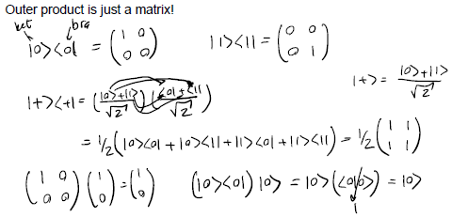

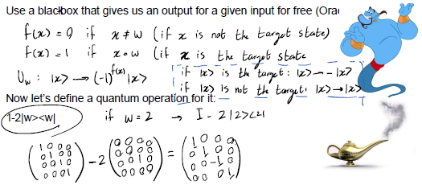

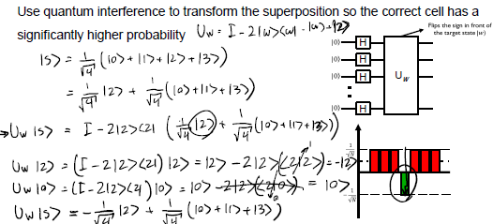

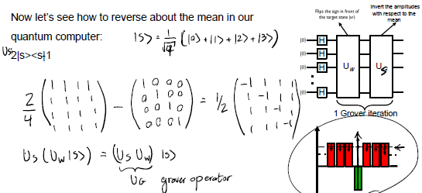

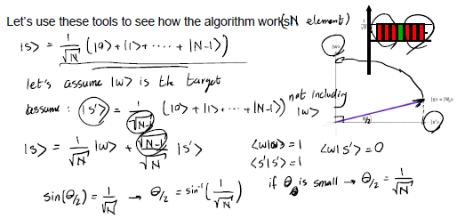

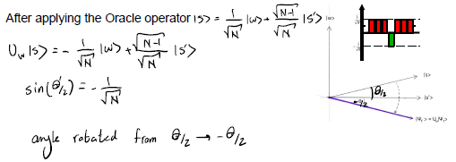

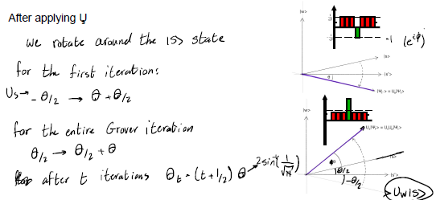

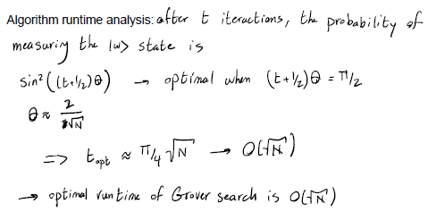

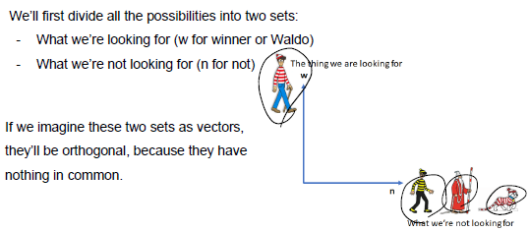

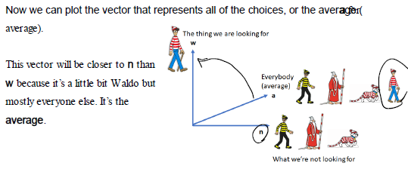

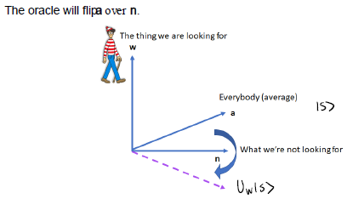

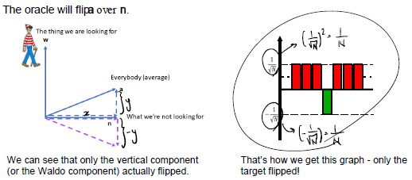

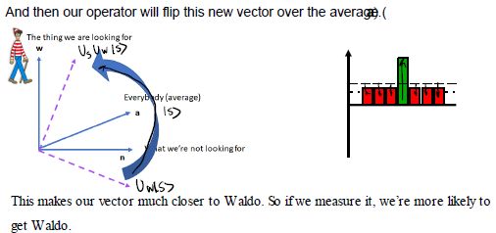

### Lab

Let s assume that Waldo is 4th in the list of 4 characters. By applying the H gates, we are starting off with equal probability amplitude in all possible states:

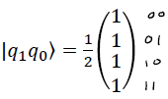

The oracle is a fancy gate that gives us answers to queries. We want the oracle to flip the sign of the state we are searching for, while leaving other states unchanged. Can you think of a gate that changes the sign of one state, while leaving other states unchanged?

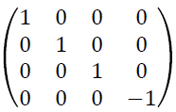 This is a controlled Z gate: 

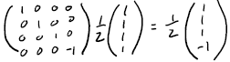

At the end, we want: 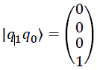So we apply Grover’s diffusion operator: 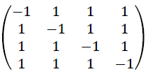

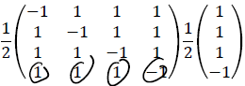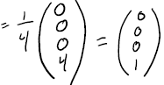

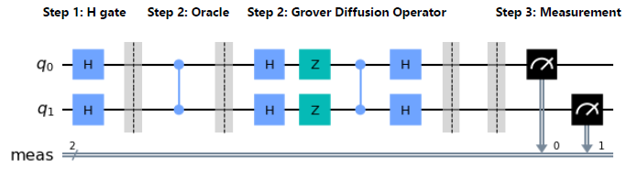

Grover s algorithm consists of 3 steps:

• Put all qubits in a superposition state by applying H gates

• Apply oracle and diffusion operator repeatedly to amplify the amplitude of the right state

• Measure

Grover s algorithm uses the quantum mechanical resources of superposition as well as the ability to change the phase of probability amplitudes to produce interference.

Week 22

Quantum Hardware

### Properties of a Quantum Computer

• Enough* qubits to run algorithms

• A way to fix errors if they occur

• A set of gates that are “universal”

• Capability to readout the state at the end of the algorithm

### Quantum Hardware Platforms

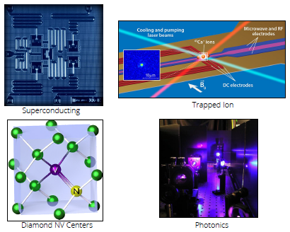

Why can’t we run Grover’s algorithm on a meaningful dataset today?

• Not enough qubits

• Noisy qubits

• Imperfect gates

### DiVincenzo Criteria

1. A scalable physical system with well-characterized qubits
2. The ability to initialize the state of the qubits
3. Long relevant decoherence* times, much longer than the gate operation time  
   decoherence times: The amount of time that the qubits preserve its quantum properties
4. A “universal” set of quantum gates
5. A qubit-specific measurement capability

Qubit Relaxation

Physical systems tend to dump energy into their surroundings. Similarly, the qubit state decays from |1⟩ to |0⟩ over time.



### Qubit Decoherence

Quantum systems lose their coherence as a result of interacting with the environment. Quantum superposition turns into a classical probability distribution. Lose the ability of quantum interference.

decoherence time: T2

Ramsey experiment:

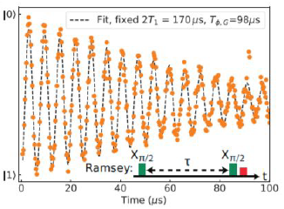

Quantum control is hard. There are a continuous set of possible position on the Bloch sphere. Lots of room for error.

We quantify quantum gates by using **gate fidelity**. Perfect gate has a fidelity of 1 (100%). One popular example is **randomized benchmarking**.

A .995 (99.5%) gate fidelity sound good, but if we have a circuit with 200 of these gates, overall fidelity will be (.995)200 = .367 (we want > .66).

### Lab (Randomized Benchmarking)

Different Types of Errors:

• Qubit errors (initialization, relaxation, decoherence, phase shift)

• Gate errors (computation)

• Readout errors (output, measurement)

What To Do About Errors:

• Characterize errors (difficulty level - easy)

• Mitigate errors (difficulty level - medium)

• Correct errors (difficulty level - hard)

• Prevent errors (difficulty level - super hard)

Characterizing Errors – Telephone Game

• You whisper a message to your friend, who whispers it to their friend, and so on.

• Up to how many levels of friends can you reliably send a message?

Randomized Benchmarking

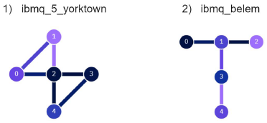

• The “message” we want to send is |00..0⟩ - our circuits should ideally produce the state |00..0⟩ as the result

• We’ll give the same circuit to both QCs to compare their performance

• From the performance, we can extract the average gate fidelity

Key Takeaways

• Randomized benchmarking is the process of testing randomly generated circuits on different quantum processors to compare their error performance

• We can simulate the error performance of different processors in qiskit by using the NoiseModel function

• Gate fidelity can be extracted from the results of randomized benchmarking

• Connectivity is also an important metric in determining processor performance. If there is a direct connection between two qubits, we can apply two qubit gates on them with fewer errors

Week 23

Quantum Hardware

### Superconducting qubits (Amir Karamlou)

Engineer artificial atoms using superconducting material that can be used a qubit.

● As electricity moves through normal material it experiences resistance

● A superconductor conducts electricity without any resistance

● Material resistance drops as the temperature gets lower

● For some material, the resistance sharply drops to 0 at a critical temperature (Tc).

● Example: Aluminum becomes superconducting at Tc=1.75K

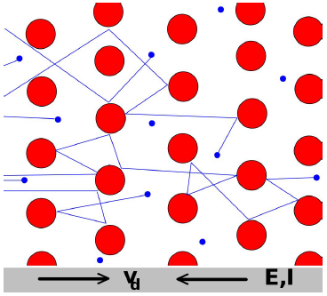 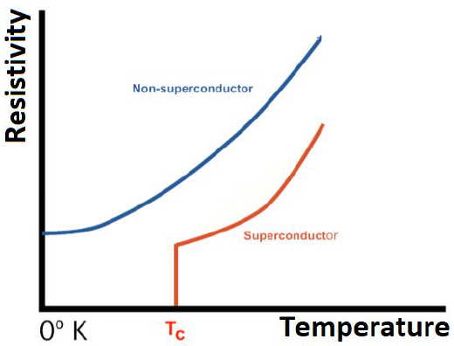

Let’s build a superconducting circuit with a capacitor an inductor.

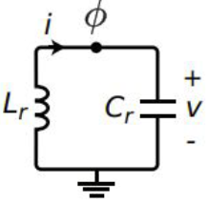 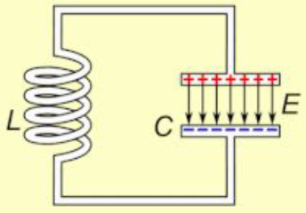

● Capacitor: stores electrical energy

● Inductor: stores magnetic energy

What do the energy levels of this system look like:

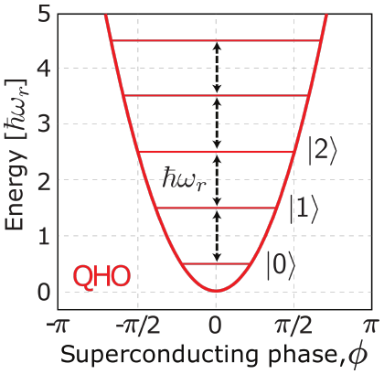

Can we use this system as a qubit?

Challenge: Ideally we want a purely two-level system

In reality: Most physical systems have many energy levels :(

Solution: replace the inductor with a Josephson Junction

What’s a Josephson Junction?

● Two superconductors coupled by a thin insulating barrier

● Current tunnels through the insulator

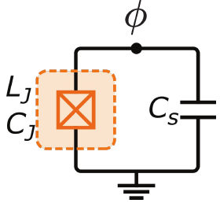 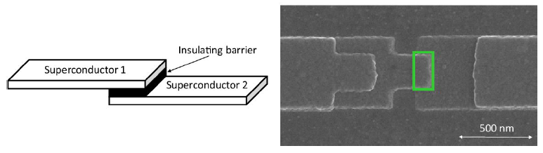

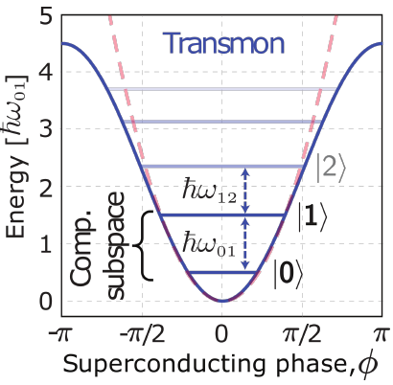

How do we operate the qubits?

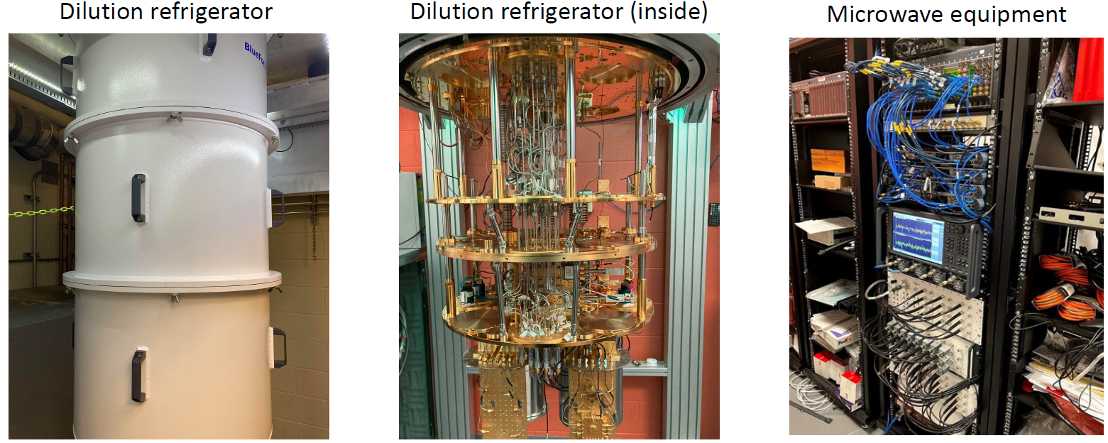

How are the qubits connected?

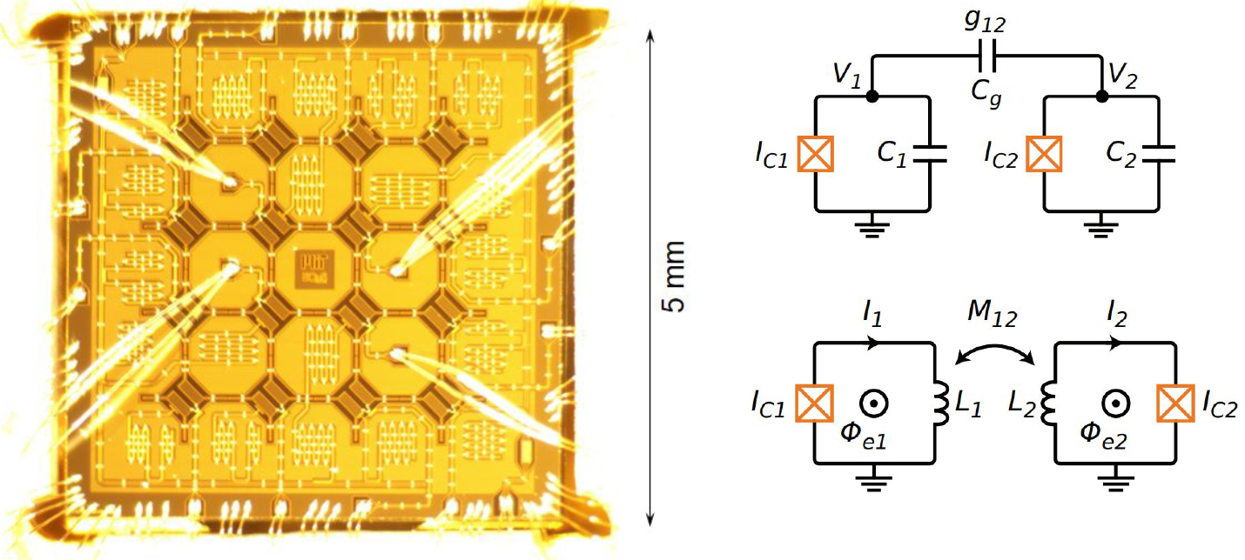

What are the coherence properties?

● State of the art T1 in quantum processors: ~100 us

● State of the art T2 in quantum processors: ~ 100 us

● Individual qubit T1s and T2s have been shown to go as high as 1ms

Average gate time: 10-100ns

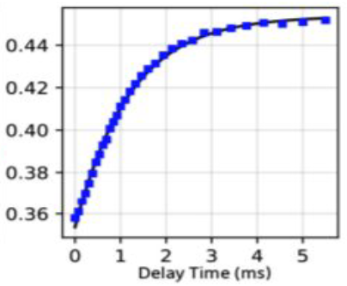 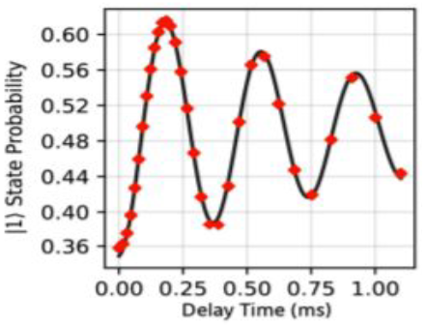

What is the gate fidelity?

● Gates can be engineered using:

○ Microwave pulse

○ Using natural hardware interactions

● Single-qubit gates: ~99.99%

● Two-qubit gate: >99.7%

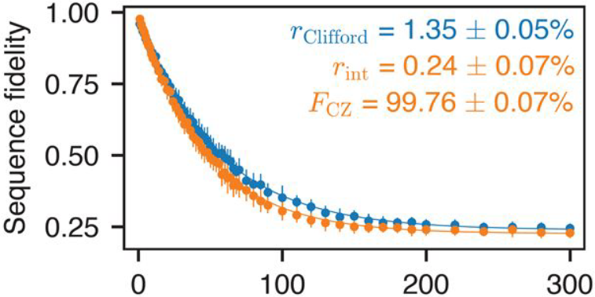

Pros:

● Comes on a chip

● Compatible with existing fabrication infrastructure

● Uses microwave technology which is well developed

● High quality gates and readout

Cons:

● Loss to substrate material

● Requires cooling to mK temperatures

● Need bigger dilution fridges for larger Processors

Ongoing research:

● Scaling to more qubits

● Higher coherence times (T1, T2)

○ New designs

○ Improvement in material

● Engineering better quantum gates

● Achieving error correction and fault tolerance

### Trapped ion qubits (David Wong-Campos)

Take mother nature’s qubits (atoms) and engineer around them.

The most ideal and clean quantum system. Based on well understood Physics.

• Best detection fidelity: 99.995(6)%

• Best single qubit gate fidelity: 99.9934(3)%

• Best Two qubit gate fidelity: 99.9(1)%

• Excellent coherence* (>10

• Reconfigurable: computation, simulation etc.

• Full connectivity

* Time it takes before it stops having quantum properties

Trapping charged atoms is relatively easy (done since the 50’s).

Step 1: Find an atom with two outer electrons

Step 2: Ionize it

Step 3: Confine it in an electromagnetic trap

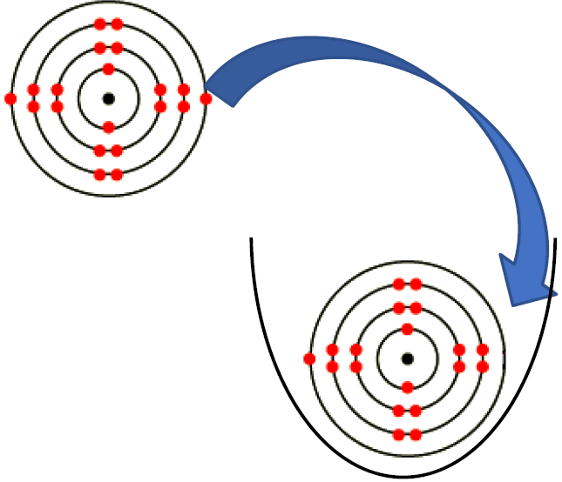

Positively charged particles are repelled by electric fields:

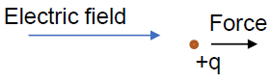

Certain configurations do a better job:

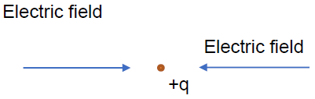

… but not quite:

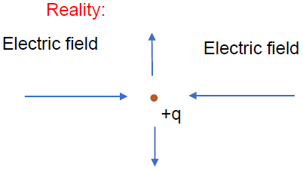

Solution: Make them rotate/oscilate

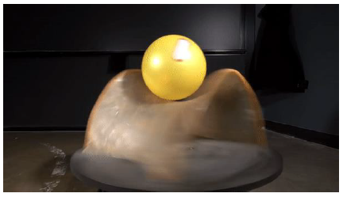

One could use the same principle for trapping many of them:

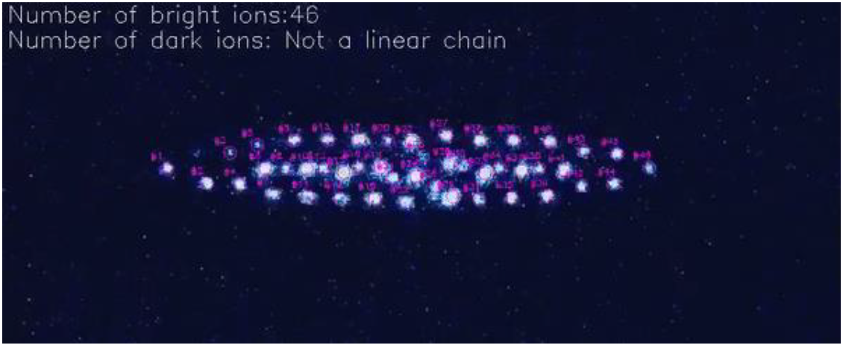

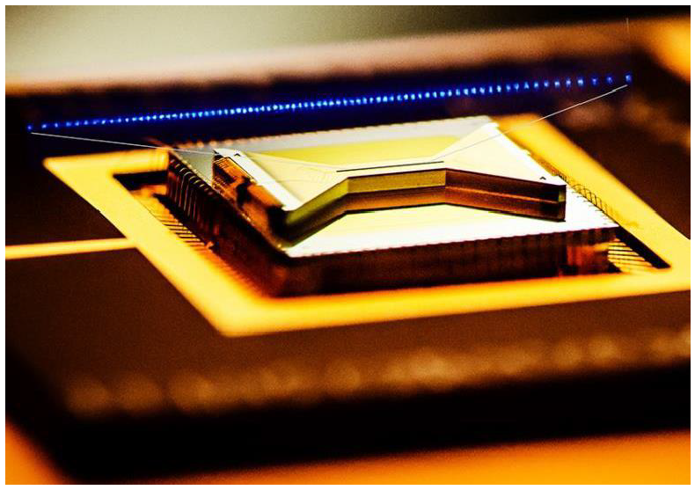

How do we operate the qubits?

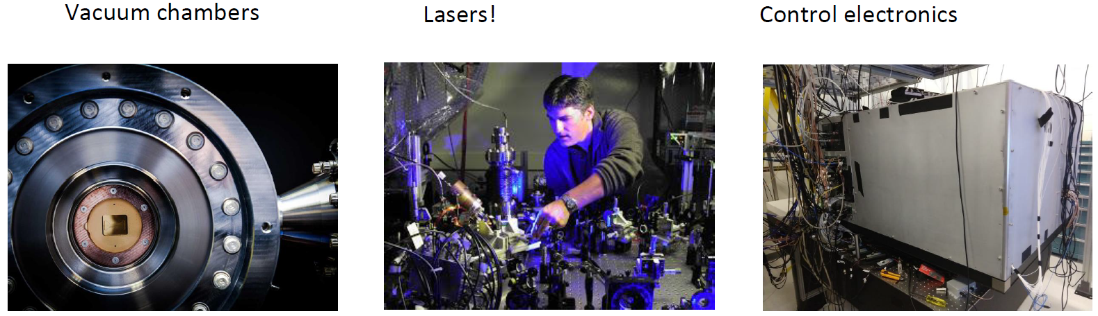

How are the qubits connected?

All the atoms “feel” everybody else They are charged*

*Like charges repel each other

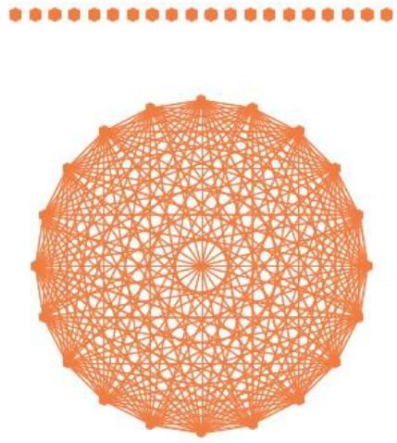

How do you control them?

Single qubit gates allow the control of “how much” 0 or 1 each qubit have.

Trapped ion qubits are pretty much two-level systems for practical purposes*

Up to really good approximations!

Fastest gates are usually around 5 microseconds.

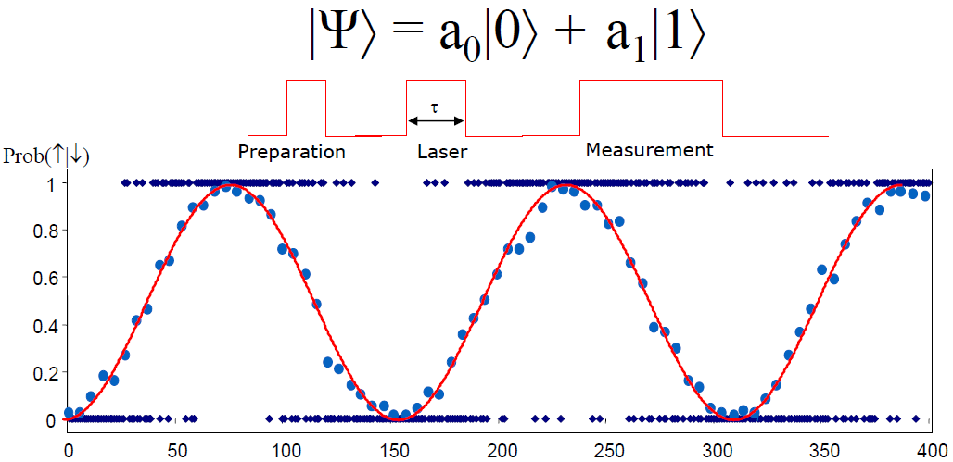

How do you perform gates?

Push individual ions with lasers

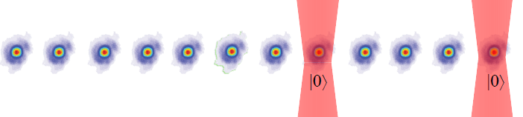

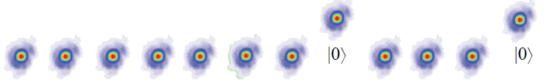

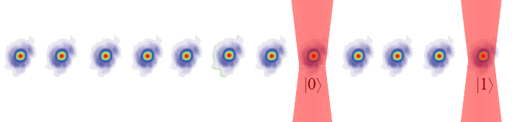

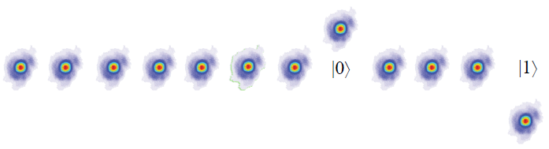

Average gate time: 5-25 microseconds

If that push depends on whether the ion is in the 0 or 1 state, it allows quantum gates!

Pros:

● Excellent quantum properties

● Traps are made with known techniques

● Laser and photonics technology is mature enough

● High quality gates and readout

Cons:

● Slow operations (for now)

● Needs vacuum

Ongoing research:

● Scaling to more qubits

● Achieving error correction and fault tolerance

● First quantum Unicorn!

### Solid state defects centers (Eric Bersin)

Take a solid material, and add a defect ok for quantum computing, great for quantum internet.

● Materials like diamond have a crystal structure

● Defect center qubit: make a “defect” replace one of the atoms with something else

● Acts like a trapped ion, but protected by the surrounding material

● Lots of different “species” of defects, in lots of different materials!

● Most popular of these is the “nitrogen vacancy” defect in diamond

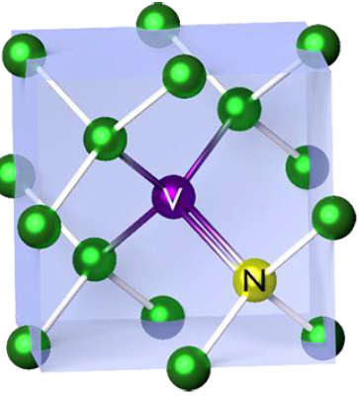 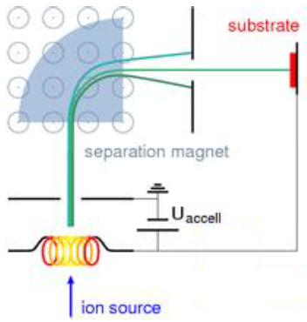

Step 1) Grow a diamond

Step 2) Implant ions

Step 3) Heat up diamond (called “annealing”) to form

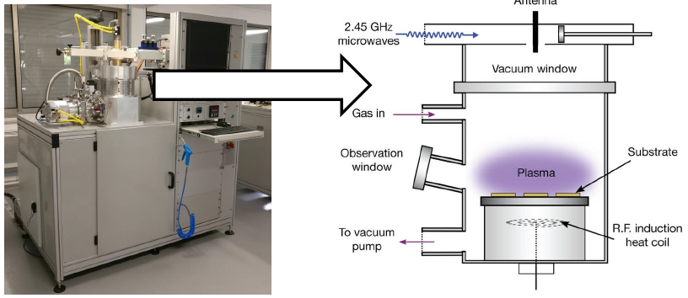

How do we use them as qubits?

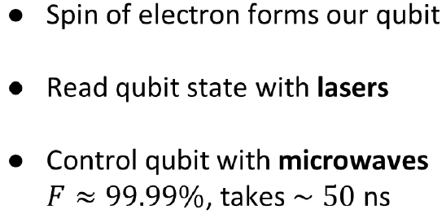

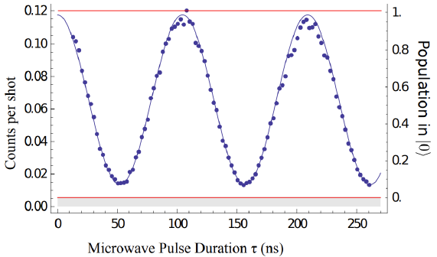

How do we operate the qubits?

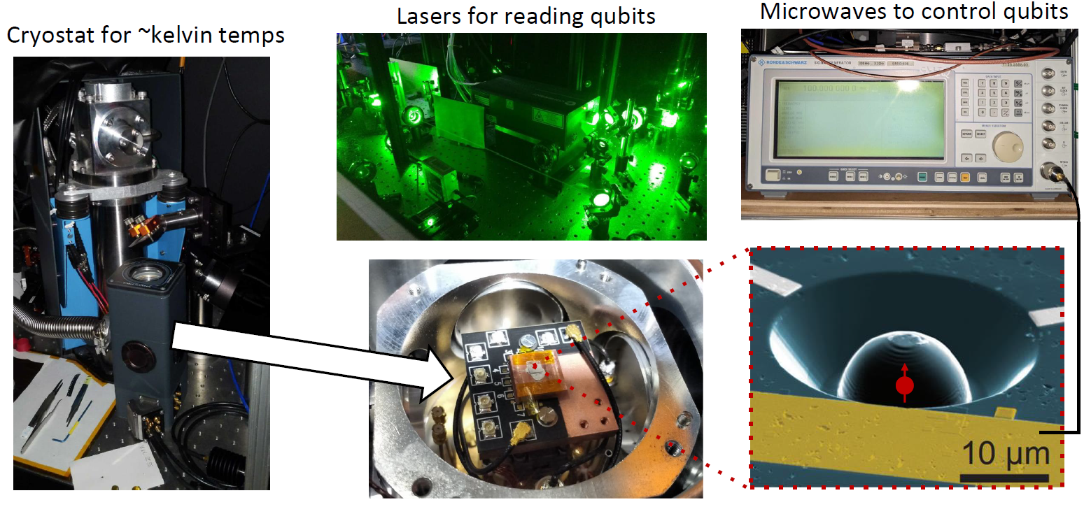

How do we entangle the qubits?

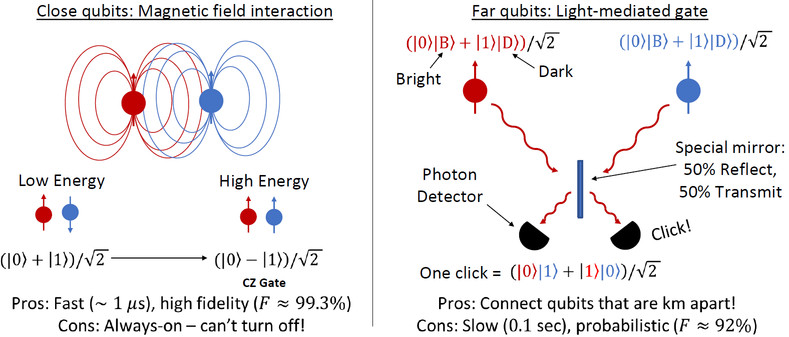

Putting them on a chip - fabrication!

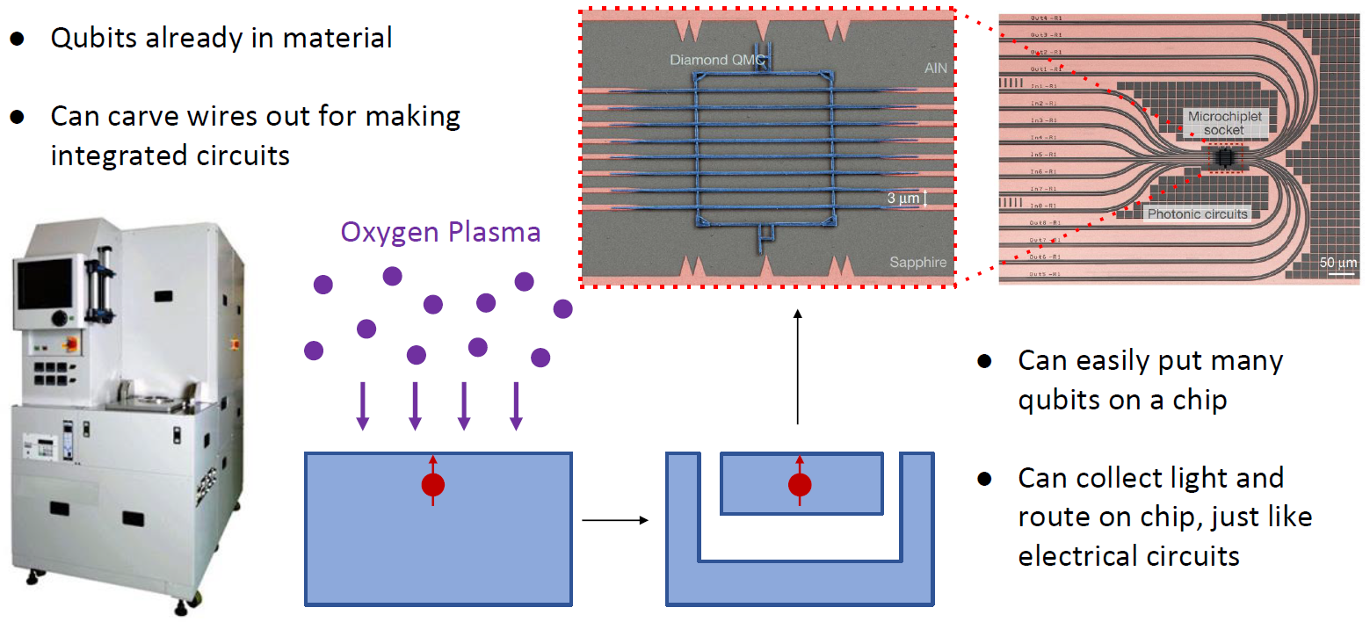

Collecting light for quantum internet

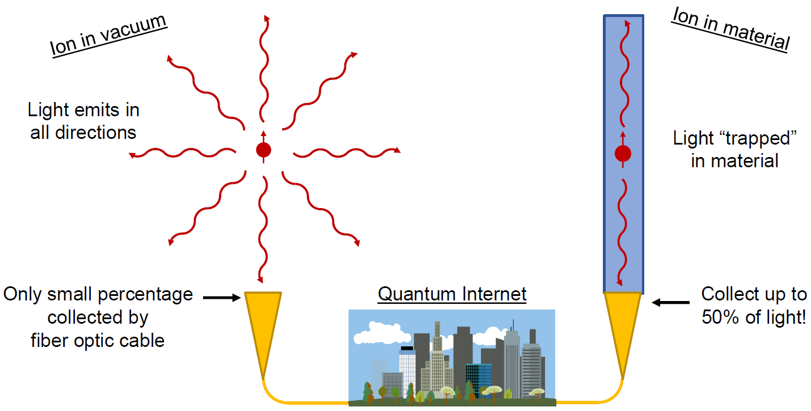

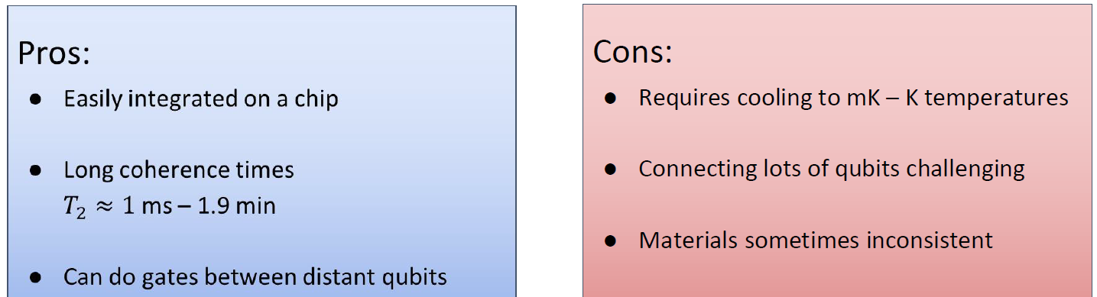

Ongoing research:

● Hunt for new species of defects in new materials

● Improvements in host materials (to further improve coherence)

● New fabrication better light controlling circuitry

● Faster, higher fidelity two qubit gates

● Putting even more qubits on one chip

### Photonic qubits (Stefan Krastanov)

Use small packets of light to carry quantum information. They are resilient to noise, but difficult to work with. Optical hardware does not need to be cooled. It also happens to be ridiculously fast. Thermal noise is a problem.

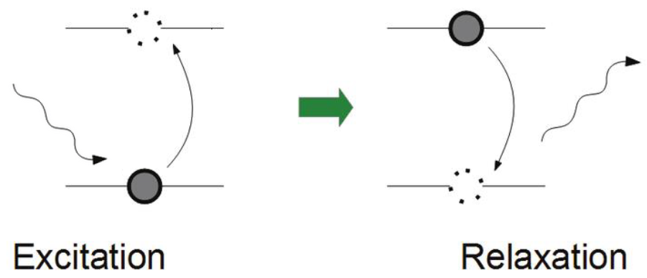

Thermal noise vs Photonic qubits

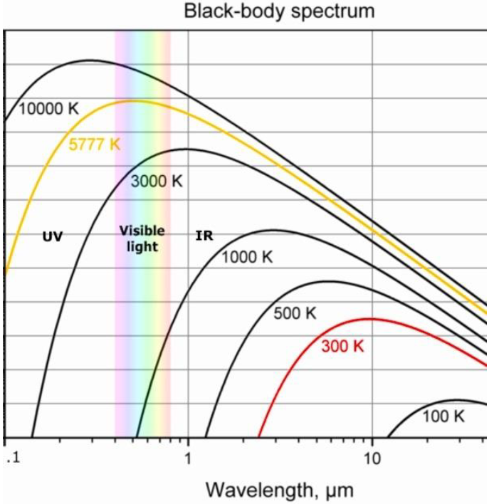

They really do not want to interact with each other. Nonlinear optics in special materials.

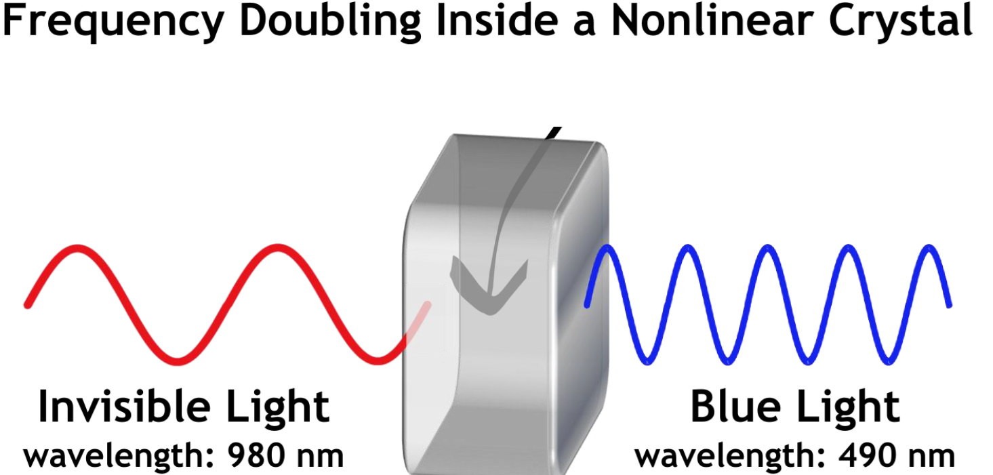

Photonic Chips:

To manipulate states of light. A chip with waveguides instead of wires.

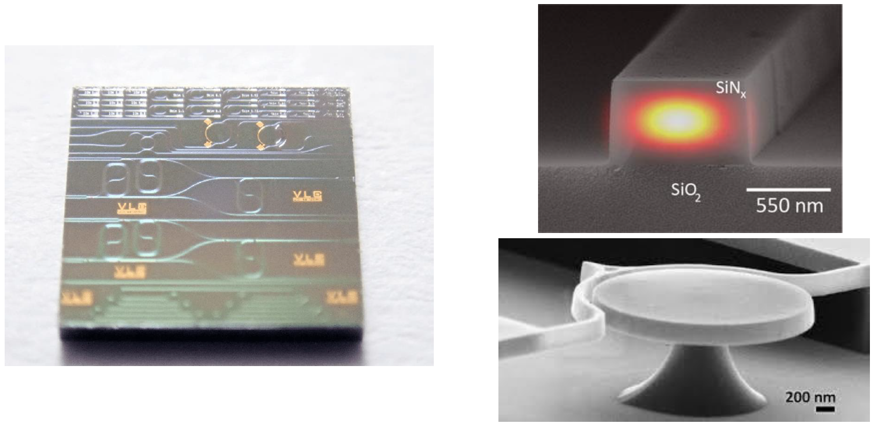

Storing light on a chip:

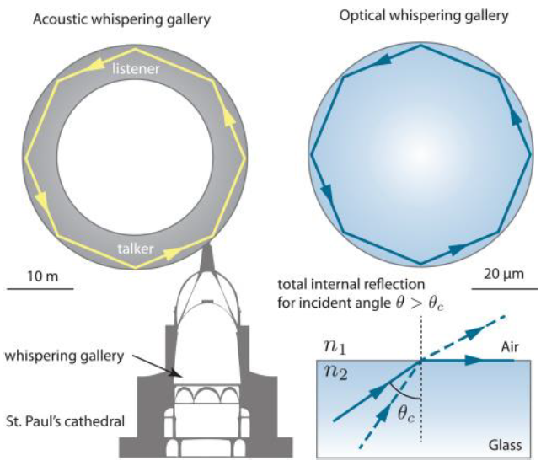

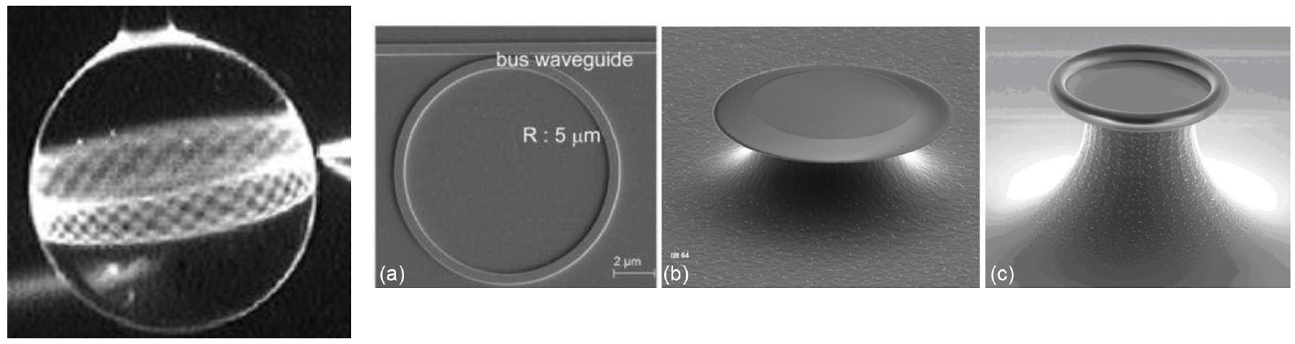

Pros:

● Comes on a chip

● Compatible with existing fabrication infrastructure

● Extremely fast

● Room temperature

● The only way to send quantum states between distant devices

Cons:

● Gates between qubits are very difficult as photons simply do not interact with each other

Week 24

Near-term Quantum Algorithms

### Motivation

What we want for quantum computing:

• No errors (no noise, error correction, perfect gates)

• No limitations on the number of qubits

• No limitations on the number of gates (circuit depth)

What we have:

• Limited number of qubits (50-200)

• No error correction -> limited circuit depth

• Known as “noisy intermediate-scale quantum (NISQ)” or simply “Near-term quantum” devices

State of the art quantum processor:

• Superconducting quantum processors

• Number of qubits: 50-100

• T1, T2 ~ 50-100 microseconds

• Two-qubit gate fidelity: 99.4%

• No demonstration of useful quantum advantage

What can we do with near-term computers?

• Find the most stable configuration of a molecule

Use cases: medicine, farming, material design

• Better optimizing complex problems

Use cases: finance, scheduling, machine learning

Quantum-Classical hybrid algorithm:

Idea: Let’s combine the small quantum computers that we have with the classical processing power that’s available to gain an advantage!

The workflow:

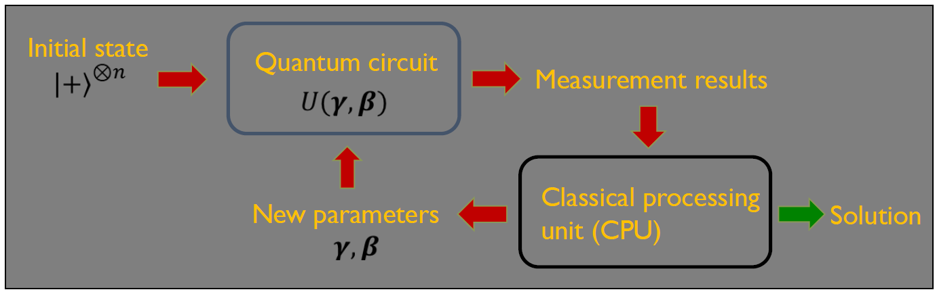

Variational quantum circuits:

idea: Let’s use “tunable” (variational) quantum circuits.

We have noisy qubits and gates, so we try to compensate by adding tunable parameters. The tunable circuit template is called an ansatz. We fill in the template with our choice for the tunable parameters!

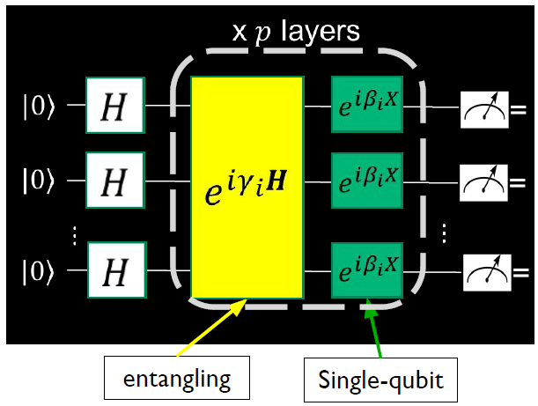

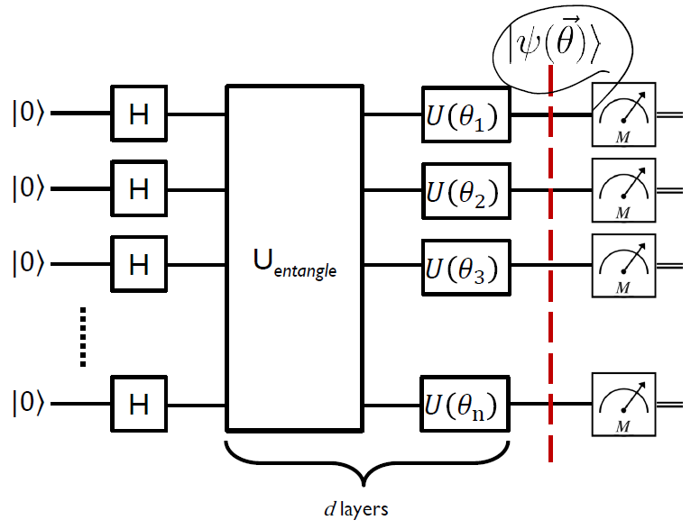

The circuit for Grover’s was pre-fixed. But we can change the parameters of the variational circuits

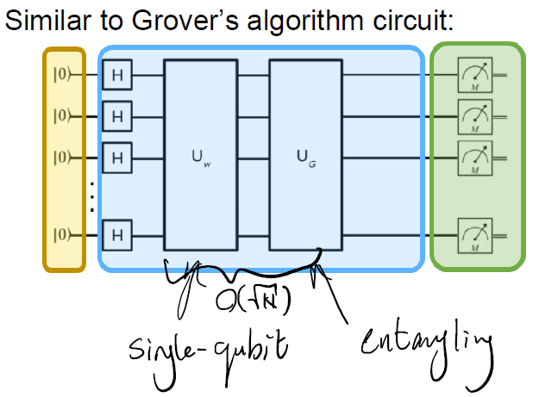

Quantum-Classical hybrid algorithms:

Few notes:

• Variational circuits are a heuristic approach, trying to imitate amplitude amplification

• Not every variational circuit is created equal

• Expressibility: how many different quantum states can we produce with our ansatz

• The art of variational quantum-classical algorithms is coming up with good ansatz

Two famous variational algorithms:

• Variational Quantum Eigensolver(VQE)

Used for continuous systems (e.g. chemistry simulations)

• Quantum Approximate Optimization Algorithms (QAOA)

Used for combinatorial optimization

Quantum Approximate Optimization Algorithm (QAOA):

A variational quantum algorithm used for combinatorial optimization problems.

Ex: Candy shop problem:

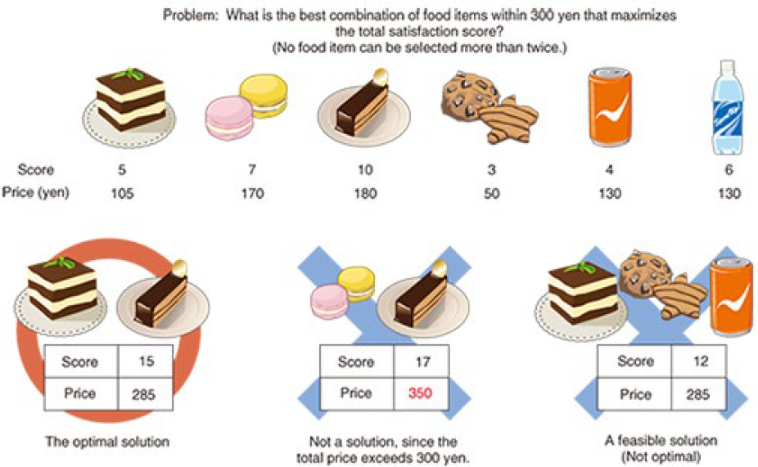

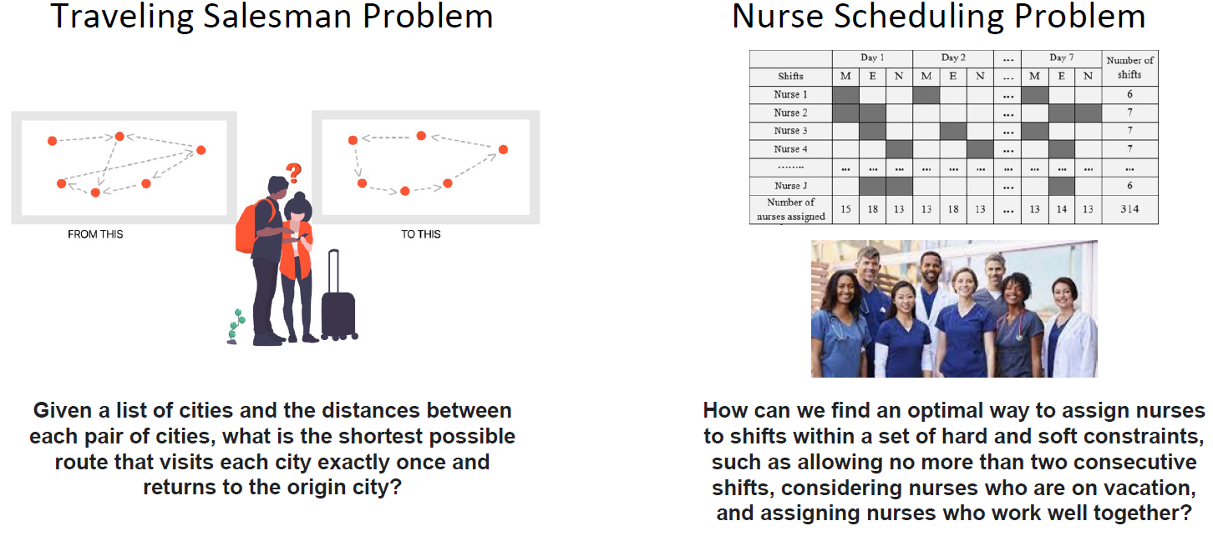

Combinatorial optimization:

Let’s consider we have:

• n bits

• m clauses (conditions)

Example:

• 3 bits: b1, b2, b3

• 2 clauses:

• 3*b1 - 2*b2 + b3

• b1 + b2 + b3

What are some values for b1, b2, and b3 that minimize the value of the clauses?

Cost function: tells us what the cost for different values of the bits are

We can define the cost function as the sum of our clauses!

Back to our example:

• 3 bits: b1, b2, b3

• 2 clauses:

• 3*b1 - 2*b2 + b3

• b1 + b2 + b3

Cost function: C(b1,b2,b3)=[3*b1 - 2*b2 + b3]+[b1 + b2 + b3]=4*b1 - b2 + 2*b3

Goal: find values for the bits (b1,b2,b3) that minimize (or maximizes) the value of the cost function!

How can we do it?

One idea: Let’s try every single combination of 0s and 1s

Problem: The problem grows exponentially with the number of bits :(

QAOA is a heuristic quantum algorithm for tackling this problem!

Translating from bits to qubits:

We need to “translate” the problem from classical bits to qubits.

Let’s map the value of a bit to an operator for a qubit.

Using this mapping we can turn a classical cost function into a quantum Hamiltonian, which a quantum computer understands.

Let’s map the value of a bit to an operator for a qubit:

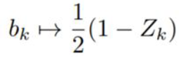

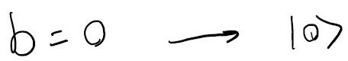

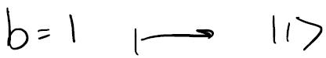

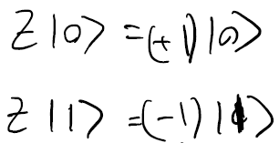

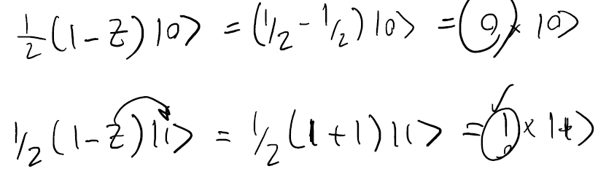

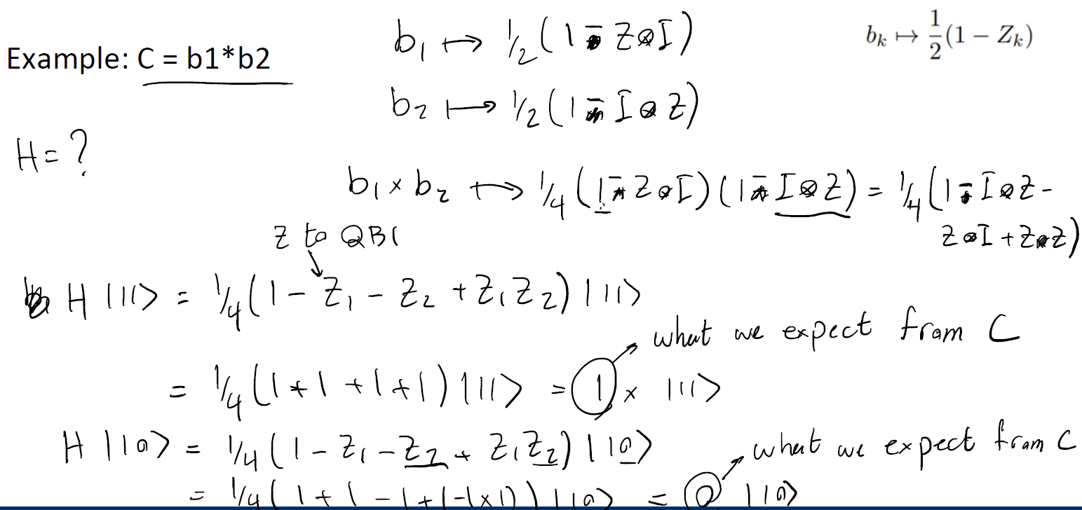

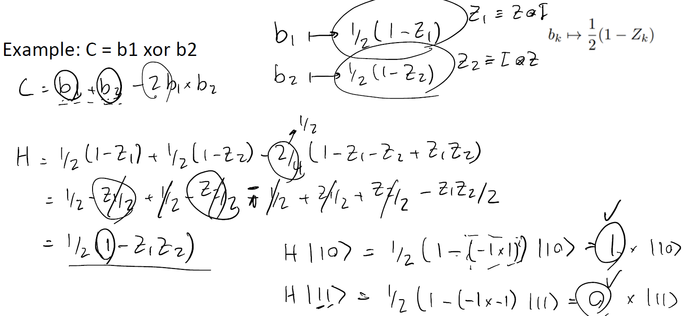

QAOA circuit:

1. Map cost function to a Hamiltonian (Hermitian) H

2. Entangling unitary of the template (ansatz)

3. Single-qubit unitary of the template (ansatz)

4. Measurement

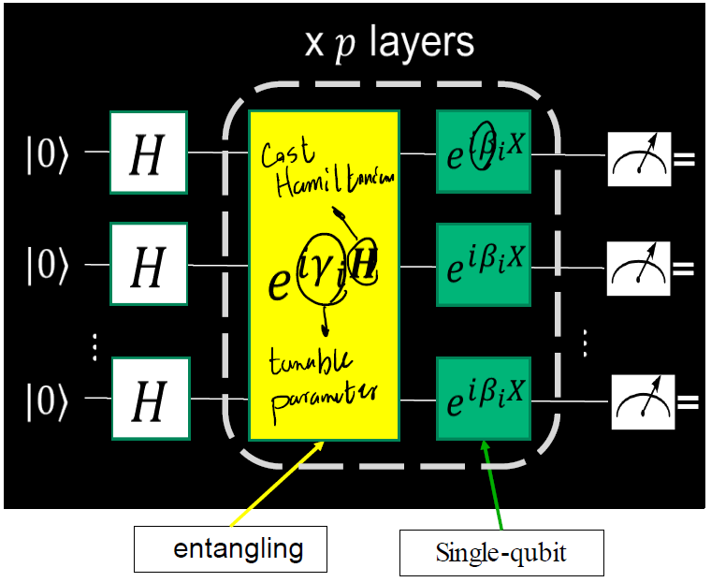

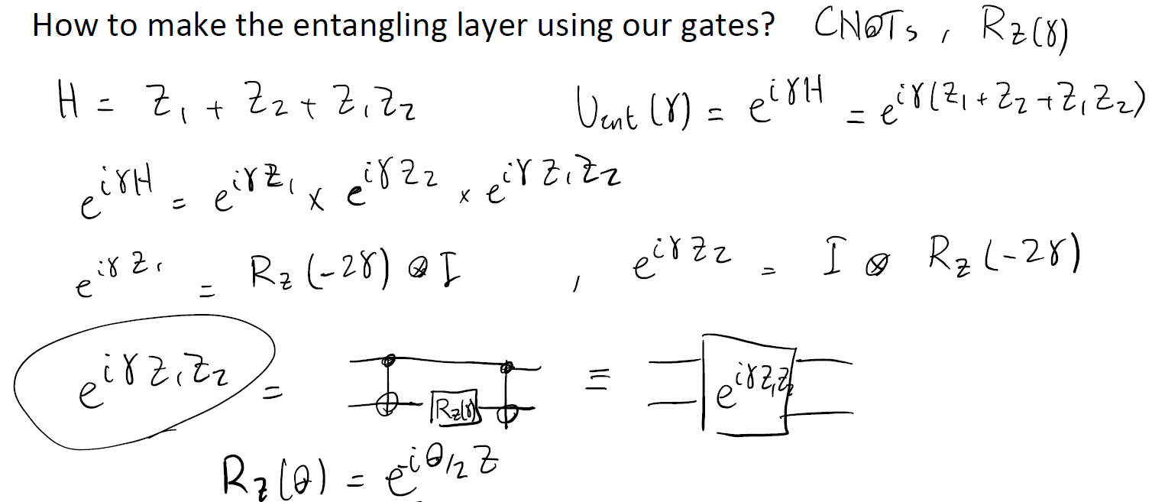

QAOA workflow:

Find the optimal parameters that minimize the expected value of the cost Hamiltonian.

